Camp 235 Gorhambury Park, Hemel Hempstead, Hertfordshire

Prisoner of War Camps (1939 – 1948) - Project report by Roger J.C. Thomas - English Heritage 2003
OS NGR | Sheet | No. | Name & Location | County | Cond’n | Type 1945 | Comments
TL 110 076 | 166 | 235 | Gorhambury Park, Hemel Hempstead | Hertfordshire | 5 |  | Precise location not identified, NGR given for centre park. English heritage site.

Location:  Before the camp:  Pow Camp: When this camp closed (1945?) the number 235 was allocated to ‘The Arches’ camp at Felden.  After the camp:  Further Information: | 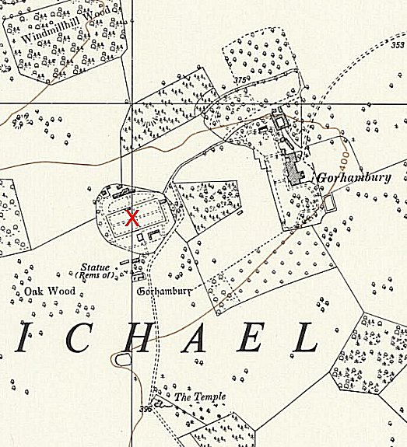
 | Ordnance Survey 1960

