Camp 234 Talgarth Military Hospital, Talgarth, Breconshire

1947 Camp List
Hospital | Talgarth Military Hospital, Talgarth, Mon | W |  | Military Registrar, Talgarth 79780 |  |  | Administered by No.99

Prisoner of War Camps (1939 – 1948) - Project report by Roger J.C. Thomas - English Heritage 2003
OS NGR | Sheet | No. | Name & Location | County | Cond’n | Type 1945 | Comments
 |  | 234 | Talgarth Hospital, Talgarth | Breconshire |  |  | Wales

Location: NGR SO 163 331 about 19 km north of Crickhowell.  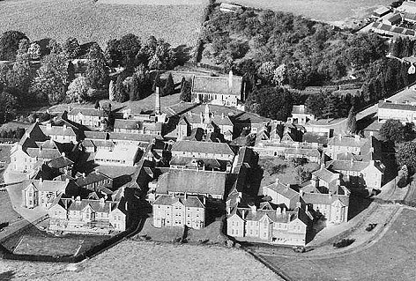  Before the camp: The lunatic asylum was opened on 18 March 1903. In April 1940, 315 beds were made available for military use.  The book ‘Up Top’ by Hugh Purcell states that Rudolf Hess was held and treated secretly at Talgarth Asylum before it became a pow camp.  Pow Camp: Administered by Camp 99, the Military Hospital in Chepstow, Monmouthshire. The section allocated for military mental health patients became the pow hospital, (date?).  Psychotic / Psychoneurotic pows were treated here. (Recorded in ‘Psychiatry in the British Army in the Second World War – Robert H Ahrenfeldt – 2018 – Routledge).  During 1945, one of the Spanish Republicans held as a pow was sent to Talgarth: | 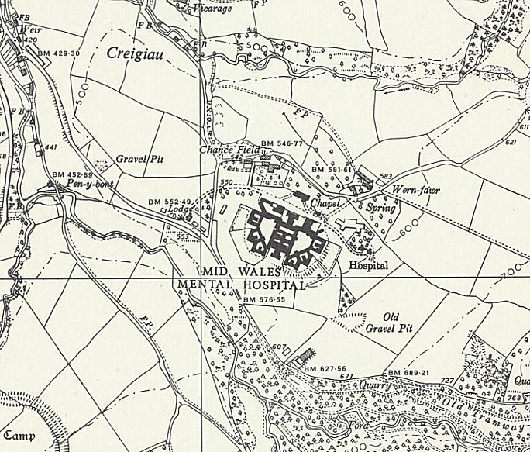
 | Ordnance Survey 1958

“Lieutenant W. Griffiths asked the Secretary of State for War for what reasons Ceferino Medero, a Spanish Republican, was removed from Hall o' th' Hill Camp, Chorley, on or about 10th December.

Mr. Lawson - This Spaniard was evacuated to Talgarth Mental Hospital on 6th October, 1945, on account of his mental condition. His fellow Spaniards had previously requested his removal, but at that time his mental state was not considered such as to necessitate transfer to a mental hospital.” (House of Commons written answers - 30 October 1945
Vol 415)

After the camp: The war department released most of their beds on 31 December 1946. The mid-Wales Mental Hospital closed in 1999. 2019 the site is derelict.

Further Information:

National Archives FO 1120/233 – Re-educational survey visit reports for camps 230 to 235. Dated 1 January 1946 to 31 December 1948

WO 177/1046 Talgarth records by the War office. Dated April 1941 to August 1944; October – November 1945.

There are many records relating to the asylum during the war years at the National Archives.

