Camp 233 Findo Gask Camp, Dunning, Perthshire

Location: NGR NO 011 212  Before the camp: The site became RAF Findo Gask in 1941 – a Flying Training Airfield. The airfield was abandoned by the RAF in 1944 and the area used by the Polish Army.  Pow Camp: (Camp number 233 previously used by Summer House camp). Used as a pow camp from the end of the war.  Raised in Parliament –  “THE EARL OF MANSFIELD asked His Majesty's Government, if they are now in a position to state the future of the aerodrome at Findo-Gask, Perthshire, both as regards the buildings, and the arable land.  LORD WESTWOOD - This airfield is no longer required by the Royal Air Force. The final disposal of the land has not yet been decided, but meanwhile it has been made available for unrestricted agricultural use. The buildings will be needed for some time for housing German prisoners who will be working on the land.” (House of Lords Deb 31 July 1946 Vol 142)  Postal items: POW letter-sheet 10 September 1946 in German to Germany  After the camp: The site was derequisitioned in 1948. 2020 Farming land and a small residential area.  Further Information:  National Archives FO 1120/233 – Re-educational survey visit reports for camps 230 to 235. Dated 1 January 1946 to 31 December 1948 | 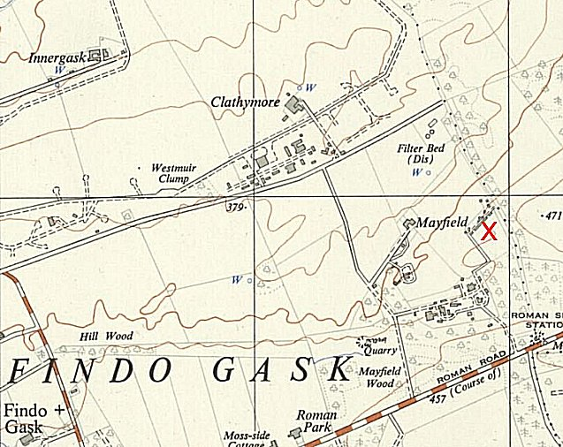
 | Ordnance Survey 1955

