Camp 139 - Wolviston Hall, Wolviston, Co.Durham (+ Coxhoe Hall)

Included in the 1945 ICRC camp list – Labour Camp. 139. Wolviston Hall, Billingham, Co.Durham.

1947 Camp list
139(G.W.C.) | Wolviston Hall, Wolviston, Billingham, Co.Durham | N. | Priswar, Billingham | Wolviston 249 | (Blank) | Major R.H.McGain | v/1452/2

Prisoner of War Camps (1939 – 1948) - Project report by Roger J.C. Thomas – English Heritage 2003
OS NGR | Sheet | No. | Name & Location | County | Cond’n | Type 1945 | Comments
NZ 454 258 | 93 | 139 | Wolviston Hall, Wolviston, Billingham | County Durham (Cleveland) | 5 | German Working Camp | Hostel

Location: Wolviston is a village on the NE edge of Billingham.  Before the camp:  Pow Camp: Italian Pows until at least 1945, then a German Working Camp.  There were 447 pows recorded at the camp in 1946.  There was a camp newspaper, “Ritt in die Zukunft” (Ride Into The Future). The camp commandant described it as; “This paper is an experiment. It is not large, but that may change if it is popular. I have great hopes that it will help you, teach you, entertain you. With your co-operation and contributions, it is sure to reach that goal.” The German camp spokesman continued: “We may not be top-notch, but the main thing is to get the horse going. Even those who have never put pen to paper may find that they can write charming stories to delight us all.” And, spurred on by a pack of cigarettes per contribution, they did. It being May, the month of the German Mother’s Day, the first piece to be handed in was a heartfelt tribute ‘To my mother’, perhaps not the dedication to reformed political thinking the commandant had hoped for, but proof of what many POWs had in their thoughts.” (The first issue was dated 14 May 1946. Extracts from; German Historical Institute London Bulletin, Volume XXX, No. 2 November 2008 - The Boys’ Own Papers: The Case of German POW Camp Newspapers in Britain, 1946–8, Ingeborg F. Hellen).  17 September 1947 – 10 pows being transported from Thorpe Hall Camp (250) to Wolviston were killed when a train hit their transport lorry. (Report under camp 250) | 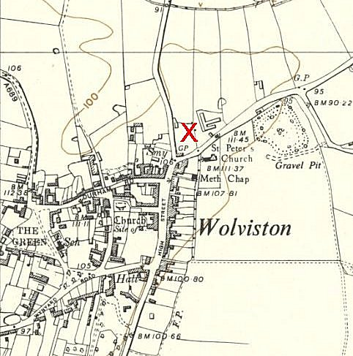
 | Ordnance Survey 1954
Sub-camps:

- Billingham

- Bishop Middleham

- Cowpen Bewley

- Coxhoe Hall – see below

- Kiora Hall (Norton) – Memories: “The first we knew of the Italian Prisoners who came in secret overnight was singing coming down Junction Road, we all stopped amazed as
those smiling Italians marched past us singing their heads off with one Soldier on a bike his rifle strapped to his back behind them. They peeled off to work in various places mainly the market gardens as food production was high priority. We got so used to them we got blasé about it, they marched down to the Church Sunday mornings though they were mainly Catholic and livened up the choir.
They left we were told long after to Canada where a lot died when the ship taking them was sunk by a U boat. [SS Andora Star was sunk 2 July 1940 – but that was too early for this camp]
We then got the Germans, same routine same jobs same marching down Junction Road with a couple of Guards on bikes, peeling off to their work places, one worked in the blacksmiths on the Green at Norton, I believe married the daughter who had been the blacksmith’s striker and stayed here. Some worked on the coal chutes at Norton Station filling bags of coal for the various coal merchants who took coal from there. Three worked for my pal Dennis Goldsborough’s dad and took turns going with him to deliver coal around the houses, it was rationed by the way. He would take them home with him at lunch time and they would all eat round the kitchen table talking away as if it was all normal. Holiday times I would often be there for lunch as my parents were both on war work. To say I was a little shocked at it all as to me they were the enemy why were they not trying to escape? That did not last long as I found they were the same as us, not Nazi’s just young men who did not want to be shot at and we had them until the war ended.
We then got the displaced people, Poles mainly, but you name it we had them, a lot married local girls and settled here.” picturestocktonarchive.com/2013/10/17/kiora-hall-roseworth-2002/ Memories from Frank P Mee.

- Manor Farm (Hartlepool)

- Sedgefield

The village of Hart also recorded pows sent from Wolviston – is this one of the camps above?

Camp commandant c.1947 Major R H McGain (Possibly Robert Henry McGain of the Pioneer Corps, who died 25 November 1947).

After the camp: Residential area.

Further Information:

- - - - -

Sub-Camp 139b – Coxhoe Hall Camp, Coxhoe, C.Durham

Prisoner of War Camps (1939 – 1948) - Project report by Roger J.C. Thomas – English Heritage 2003
OS NGR | Sheet | No. | Name & Location | County | Cond’n | Type 1945 | Comments
NZ 322 357 | 93 | 139b | Coxhoe Hall Camp, Coxhoe | County Durham | 5

NGR for hall; NZ 331 358  The Hall was built in 1725. It was bought by East Hetton Colliery in 1938. Requisitioned during WW2.  After the war the hall fell into disrepair and was demolished in 1956. | 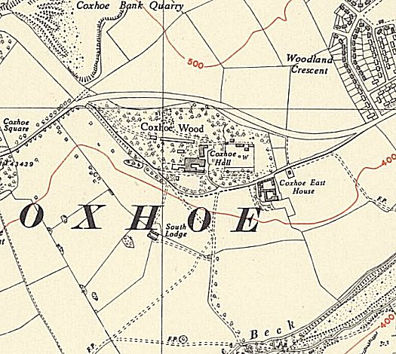
 | Ordnance Survey 1951

