Camp 232 – Northwick Park Military Hospital, Blockley, Gloucestershire

1947 Camp list
232(Hospital) | 232 P.W. Hospital, Northwick Park, Blockley, Glos. | S. | Priscamp, Blockley | Moreton-in-Marsh 135/6 | Blockley | Major W.L.Hughes | v/1416/1

Prisoner of War Camps (1939 – 1948) - Project report by Roger J.C. Thomas – English Heritage 2003
OS NGR | Sheet | No. | Name & Location | County | Cond’n | Type 1945 | Comments
SP 168 365 | 151 | 132 | Northwick Park Hospital, Blockley | Gloucestershire | 1

NOTE – I can find no reference to this camp being numbered 132 – possibly an error and should be 232.

Location: Between Chipping Campden and Blockley  Before the camp: The estate belonged to the Spencer-Churchill family. The US Army directed the construction of the Military Hospital in 1943 on a site known as the cinquefoil. It was built by Higgs and Hill Limited. The MH was called the 327th Station Hospital.  Pow Camp: 55 Nissen huts (recorded in 1947), with structures needing firmer bases such as toilet and shower blocks being brick-built. The camp was surrounded by barbed-wire fencing with wooden guard towers.  The hospital was put under the control of the International Committee of the Red Cross (ICRC) on 1 June 1944 and became Hospital 232. In the first few months only part of the military hospital site was used for pows.  An American Red Cross report in June 1944 commented that there were a large number of German pows; “It was his [the CC’s] decision that we should give them cigarettes until they get PX rations, but no comfort articles. He also OK’d giving them old magazines, chess and other checker games. Other than that, we have nothing to do with the POWs.” * German medical officers would have staffed the hospital for the pows.  On 20 September 1944 it was decided to hold only pows at the site. The American service men and medical staff were moved to other hospitals. Supervising medical staff and administration came under British personnel.  Camp commandant June 1944 to June 1945; American Colonel Benny Alfred (or Arthur) Moxness (1899-1991). | 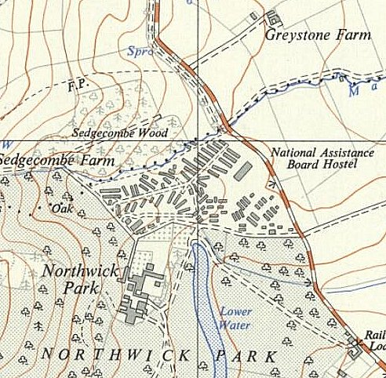
 | Ordnance Survey 1952
Camp commandant April 1946 to April 1947: Lieutenant Colonel William John Robertson, from the Royal Army Medical Corps.(1892-1964)
Camp commandant April 1947 Major W.L.Hughes

After the camp: When the hospital closed, the site was taken over by the Ministry of Works and Ministry of Health. From 1948 to the mid-1960’s it was used as a Polish resettlement camp. 2019 Northwick Business Centre.

Further Information:

‘Inside The Wire’ – Ian M.C. Hollingsbee, 2014, The History Press. A chapter on Northwick Park - * extracted from here.

London Metropolitan Archives, have details of all the tenders by Higgs and Hill – ref B/HIG

Details of the Polish Camp - www.polishresettlementcampsintheuk.co.uk/northwick00.htm

National Archives FO 1120/233 – Re-educational survey visit reports for camps 230 to 235. Dated 1 January 1946 to 31 December 1948

