Camp 231 Redgrave Park Military Hospital, Diss, Norfolk

1947 Camp List
231(Hospital) | 231 P.W. Hospital, Redgrave Park, Diss, Norfolk | E. | Priswar, Diss | Diss 280 | (Blank) | Major G.W.I.Thomas | v/1416/1

Prisoner of War Camps (1939 – 1948) - Project report by Roger J.C. Thomas - English Heritage 2003
OS NGR | Sheet | No. | Name & Location | County | Cond’n | Type 1945 | Comments
TM 054 773 | 144 | 231 | Redgrave Park Hospital, Diss | Suffolk | 4 |  | Military Hospital. Some footings remain

Location: Pow Camp 56 Botesdale was very close by – just across the lake at the bottom of the map.  Before the camp: Large country estate and hall. Used as a hotel and country club in the 1930’s.  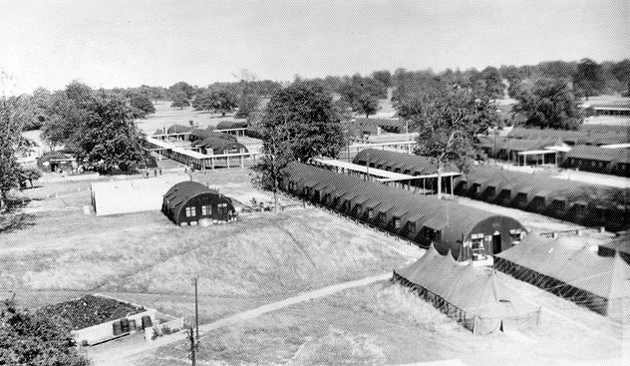  < The Military Hospital –  Approximately 35 Nissen huts that housed wards, headquarters, a dispensary, operating rooms, and laboratories.  Memorial at the park – “Redgrave Park: 65th General Hospital U.S. Army  During World War II, the 65th General Hospital, a reserve unit of Duke University, Durham, North Caroline USA, was located here on the grounds of Redgrave Park.  Of Nissen Hut construction, supplemented by ward tents, the hospital had 1456 beds and served from February 10th 1944 to August 20th 1945 as the major hospital centre for the surrounding U.S. 8th Air Force. In addition, after D Day, June 6th 1944, it treated thousands of wounded soldiers moved here from the war on the continent.” | 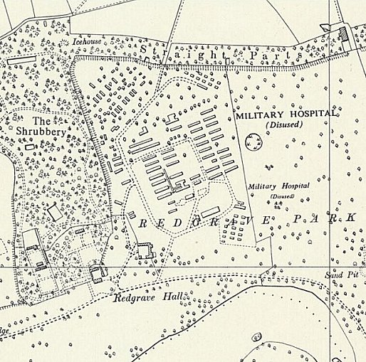
 | Ordnance Survey 1958

Pow Camp: A fenced-off section of the military hospital was used to treat pows of all ranks.

Some very senior German officers were held here, including Field Marshalls Erich Von Manstein, (30 April 1948 – 16 August 1948); Gerd von Runstedt, (4 May 1948 – 23 July 1948); and Walther von Brauchitsch, (uncertain dates mid 1948).

Some Pows were sent back to Germany using Red Cross hospital trains from Diss station.

The camp was also used as a hospital for Ukrainian pows.

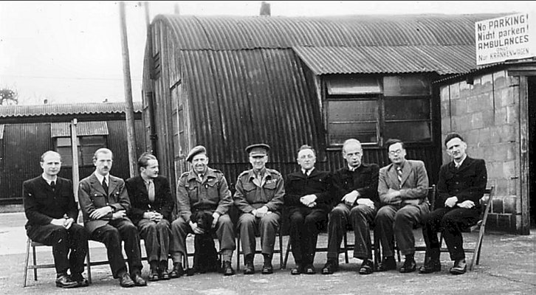
< The caption for the picture is ‘Leaders of the Ukrainian P.O.W. camp’. It is dated 23 December 1947. Note the sign in English and German for ‘No Parking’- Ambulances Only’.

Anna Sochocky has written of her father at the camp – “While he waited to be processed and released, my father worked as the Chief Medical Officer at the British camp located near the Norfolk village of Redgrave until the end of 1948. He received his Aliens Order Certificate of Registration on New Year’s Eve that year. Government officials interviewed my father for the final time on December 4, 1950, in Ipswich, England. Redgrave Park, more of a processing camp, really, with a labyrinth of Nissen huts penned in by barbed wire, was only a few miles from my mother’s childhood home. Camps like Redgrave Park dotted the English landscape for years after the armistice, but few remnants of these camps remain today.” Her father is in the centre of the photograph in civilian clothes, I wonder if the man next to him in the centre is the Camp Commandant, Major G.W.I.Thomas?

Camp commandant c1947 Major G W I Thomas (I think he was with the Royal Army Medical Corps).

Postal Items: POW letter-sheets 16 September 1947 to 26 August 1948 in German to Germany.

After the camp: The hall was demolished in 1946.

Further Information:

National Archives FO 1120/233 – Re-educational survey visit reports for camps 230 to 235. Dated 1 January 1946 to 31 December 1948

1’50” video of the military hospital - http://digitaldukemed.mc.duke.edu/sixty-fifth/life.html

www.annasochocky.com/single-post/2016/04/13/Tucked-between-the-pages-of-history

