Camp 230 (& 618) Stuckenduff Camp, Shandon, Dunbartonshire (aka Shandon)

Included in the 1945 ICRC Camp List – Labour Camp. 618. Stuckenduff, Shandon, Helensburgh, Dumbartonsh.

1947 Camp List
230(G.W.C.) | Stuchendoff Camp, Shanden, Helensburgh, Dumbartonshire | Sc | Priswar, Helensburgh | RHU 334 | (Blank) | Major S.H.Anstey | v/1452/2

Prisoner of War Camps (1939 – 1948) - Project report by Roger J.C. Thomas - English Heritage 2003
OS NGR | Sheet | No. | Name & Location | County | Cond’n | Type 1945 | Comments
 |  | 230 | Stuchendoff (Stuckenduff) Camp, Shanden, Helensburgh | Dumbartonshire |  | Base Camp | Scotland

Location: The camp was located on the E side of Gare Loch in the grounds at Stuckenduff and Ardgare House NS 257 859. Stuckenduff Farm is located at NS 259 864.  Before the camp:  Pow Camp: Over 60 Nissen type huts.  The Helensburgh and Gareloch Times gave a report on the camp in April 1947:  “As regulations are relaxed, life in a prisoner of war camp becomes much more bearable for the inmates.  At Stuckenduff Camp near Shandon over 500 Germans live, to a considerable degree free from the restrictions one associates with a prison camp. The Germans really run the camp. They have their own police force, cooks, bakers, interpreters, doctor and chaplain. They organise their own sport and spare-time activities. Through the week they work on the Loch Sloy Hydro-Electric Scheme, some being conveyed by train to Inveruglas and others by bus to Butterbridge, beyond Rest and Be Thankful.  They are good, hard workers and are paid at the rate of one and half pence per hour. This pay can only be used in their canteens for such extras as cigarettes and notepaper. Their food is similar in calorific value to that of the British Army ration, but it differs greatly in form, and as far as practicable their tastes are catered for. The Commandant has, as one of his assistants, keeping the camp accounts, a German who was formerly an official of the Reichsbank in Berlin.  A camp newspaper called the ‘Randblick’ [sic – ‘Rundblick’ = Panorama] is edited and printed in the camp, and though it is subject to censorship, the prisoners are allowed great freedom in their writings on international as well as local affairs.  In their spare time they play football — their team has attained considerable skill and can give a good account of itself against much more experienced local clubs. They also play a game similar to netball. Many are keen walkers and can be seen on the Garelochside | 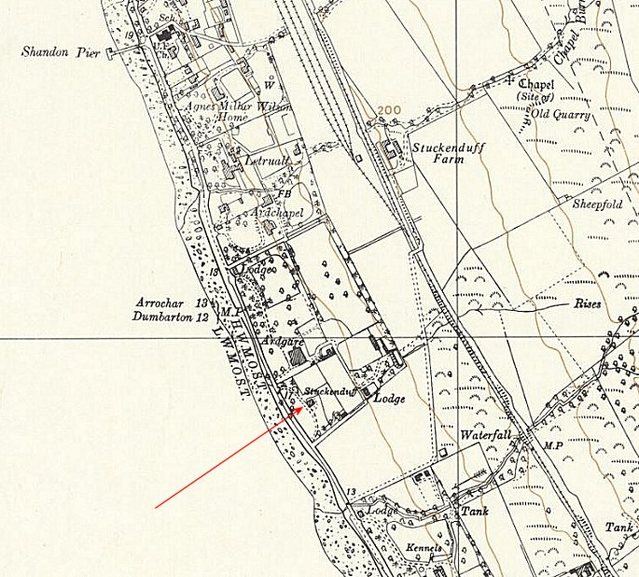
 | Ordnance Survey 1958
Road and strolling in the streets of Helensburgh. As a race the Germans were pioneer hikers and in the pre-war years flocked to the many beautiful parts of their homeland. Hikers with their rucksacks were a familiar sight in the Black Forest and on the Harz Mountains, and indeed at all the beauty spots.

In the evenings they hold whist drives and concerts. They provide their own band and male voice choir which are very popular and contain some outstanding talent, a fact not surprising when one remembers the musical genius of their race. On Sundays, parties of prisoners attend church services and their fine singing has been much appreciated by the congregations.

The Commandant estimates that at least 80% of the prisoners now believe that the only satisfactory way to rebuild Germany is by a democratic form of Government. They are keen to learn English and to study our way of life. Of Hitler, they don’t want to speak. They seem to want to forget him completely and banish the thought of him into oblivion.
Almost 200 prisoners are invited to local houses every weekend and they are most appreciative of the kindness shown them. This hospitality shows the prisoners the way back to normal life, after, in some cases, being years behind barbed wire. The opinion prevails that after having contact with our people the Germans overcome the prejudices they were burdened with and learn that we only want a long and lasting peace and understanding among nations.

Always clever with their hands, many of the prisoners are expert toy and model makers, and using only odd pieces of wood and metal found on the foreshore, they have produced many amazingly ingenious articles. They are not allowed to sell or exchange these with outsiders but can give them away on obtaining permission from the Commandant. On occasion, however, their desire to obtain extra cigarettes overcomes them and they endeavour to smuggle their handiwork out of the camp. Though no rigorous guard is kept, if a prisoner is seen leaving camp with a sizeable article he is stopped and his work confiscated. The other day when the Commandant was walking in his garden, which is adjacent to the camp, he noticed something covered with sacking hidden among the bushes. On investigation he found a beautifully made child’s wheelbarrow which had obvious been hidden there after dark and would be collected later and delivered to its unlawful destination. It was confiscated, and in the next issue of ‘Randblick’ a notice appeared asking prisoners not to compromise the Commandant in their unlawful activities.”

Memories by Shandon resident Mrs Elinor Grummitt – “My mother used to take me to Stuckenduff Farm to buy eggs, and we had to pass the camp,” she says. “I always felt a bit apprehensive at the sight of the German POWs in their brown trousers and tunics with the letters POW on the back — but on reflection they probably did not pose any threat to local people. In fact they seemed to become part of the community, as I remember one Christmas in particular when they were escorted along to Shandon Church for the Christmas service. When 'Silent Night' was sung, one POW I could see had tears running down his cheeks. And I am sure he wasn't the only one.

“They also made a wonderful gesture, to the delight of the children of Shandon Sunday School, by presenting to us at our Christmas party toys which they had made from driftwood collected from the beach. Each boy received a wooden hobby horse, and each girl a doll's rocking cradle. The toys were beautifully made and brightly painted, and gave us endless hours of enjoyment. I do believe one or two of the POWs actually stayed on in the locality after the war. I can't confirm it, but one, I believe, worked at Stuckenduff Farm.” (From the Helensburgh Heritage website – see below).

In 1946 the camp held German pows from America who had expected to be returned to Germany. For a while many refused to work. (See article by Paul Golz at the Helensburgh Heritage site).

Paul Bondy, a visiting lecturer to the camp in November 1946, noted that there was a main camp and two satellite camps with 1,224 pows.

Postal items: POW letter-sheets dated 1946, and from Germany to the camp dated 16 January 1947

After the camp: 2020 residential area.

Further Information:

National Archives FO 1120/233 – Re-educational survey visit reports for camps 230 to 235. Dated 1 January 1946 to 31 December 1948

www.helensburgh-heritage.co.uk/ - Site of the Helensburgh Heritage Trust with several articles about Stuckenduff and other local pow camps.

IWM have a copy of the camp magazine Rundblick dated April 1947, Catalogue LBY E.J.412

http://canmore.org.uk/site/272623

Vertical air photographs (106G/Scot/UK 85, 4147-4149, flown 10 May 1946

