Camp 200 Llanover Park, Llanover, Abergavenny, Monmouthshire

Included in the 1945 ICRC Camp List – Base Camp. 200. Llanover Park Camp, Abergavenny, Mon.

1947 Camp List
200(B.C.) | Llanover Park Camp, Llanover, Abergavenny, Mon. | W. | Priswar, Llanover | Abergavenny 560/1/2 | Nantyderry | Lt.Col.P.L.Crimwood, M.C. T.D. | v/202/4

Prisoner of War Camps (1939 – 1948) - Project report by Roger J.C. Thomas - English Heritage 2003
OS NGR | Sheet | No. | Name & Location | County | Cond’n | Type 1945 | Comments
 |  | 200 | Llanover Park Camp, Llanover, Abergavenny | Monmouthshire (Gwent) | Base Camp | Wales

Location: The buildings beside Llanover House are at NGR SO 312 086  Before the camp: Country House and Estate. US troops stationed at the site prior to D-day.  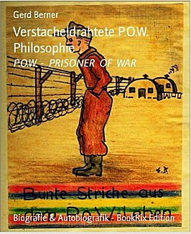  Pow Camp: Italian and later German pows. One history records that Italians were held here, the site was taken over by US troops, and then it reverted to being a pow camp, but this time for Germans. (Abergavenny’s War – Tim Butters – 2017 – Amberley Books). This fits in with a couple of postal items seen – US letter May 1944 (Camp 184 Lllanover) and POW letter-sheet 10 December 1946 in German to Germany.  Llanover Village Hall was originally built during WW2 by Italian POWs, then relocated to its current location and added to over the years.  < There is a book of pictures and poems (in German) by Karl-Gerhard Berner based on his time as a pow at Kempton Park and Llanover (Winter 1946 / 1947).  Pows returning from Canada and expecting to be returned to Germany were | 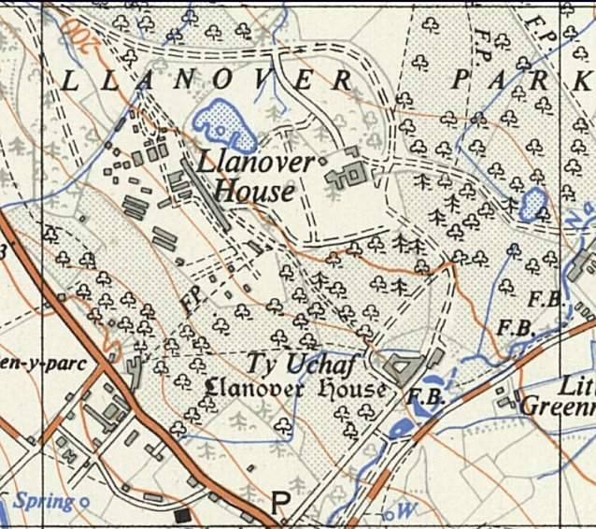
Ordnance Survey 1956.
(Buildings at side of Llanover House are not there in 1964)
held at this camp. This included some officers. One officer was Gerhard Stamer from U35. Initially he was held at Grizedale before being sent to Canada – on his return he was held at Sheffield, Lllanover Park and Lllanmartin.

There was a brief comment officers in the House of Commons:
“Major Bramall asked the Secretary of State for War how many officer prisoners of war at No. 20 [sic] Prisoner-of-War Camp, Llanover Park, have volunteered for work outside the camp; how many are actually working; and how many of those who have volunteered, but are not working, are graded C.

Mr. Bellenger - Between 60 and 70 officer prisoners of war at this camp have volunteered for work outside the camp, and they are all working.” (Hansard - 25 February 1947,
Vol 433).

After the camp: Used for emergency housing – based on comments from forum about memories of being a child born at the camp in 1949. 2020 park and farm land.

Further Information:

Verstacheldrahtete P.O.W. Philosophie (Barbed Wire POW Philosophy) – produced by Gerd Berner, based on his father’s work – 2012 - BookRix

