Camp 199 Ystrad Camp, Carmarthen, Carmarthenshire

Prisoner of War Camps (1939 – 1948) - Project report by Roger J.C. Thomas - English Heritage 2003
OS NGR | Sheet | No. | Name & Location | County | Cond’n | Type 1945 | Comments
 |  | 199 | Ystrad camp, Carmarthen | Carmarthenshire |  | Base Camp | Wales

Location: The HER description states; “A prisoner of war base camp established following the evacuation of the camp in 1944 by the United States Army.”  However, the military camp is recorded at SN 3994 1915 (Y) while the pow camp is recorded at SN 3889 1908 (X). These are two different locations.  Ystrad is to the right of the map at SN 399 189. 1.5 km SW of Carmarthen.  Before the camp: Site used by Royal Marines, a Belgian battalion, and the US Army 38 Infantry Regiment, 2nd Battalion Regimental Combat Troops.  Pow Camp:  After the camp: X - 2020 part industrial estate, part woodland. Y – residential area.  Further Information:  National Archives FO 939/338 – 199 Base Camp, Ystrad Camp, Carmarthen, South Wales. Dated 1945 – 1946.  ‘Twentieth Century Military Sites: Second World War and later Camps and Ranges’ – by Alice Pyper and Marion Page - Dyfed Archaeological Trust – 2015.  US 1944 US Aerial Photograph, Medmenham Series M1272; | 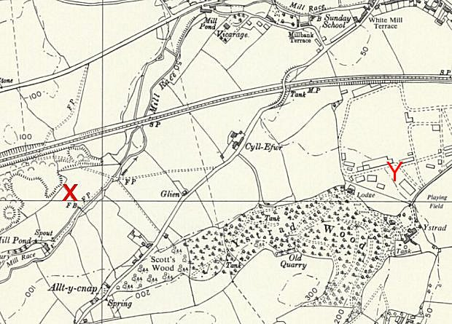
 | Ordnance Survey 1964

