Camp 197 The Mount Camp, Chepstow, Monmouthshire

Prisoner of War Camps (1939 – 1948) - Project report by Roger J.C. Thomas - English Heritage 2003
OS NGR | Sheet | No. | Name & Location | County | Cond’n | Type 1945 | Comments
 |  | 197 | The Mount, Chepstow | Monmouthshire (Gwent) | Base Camp | Wales

Location: NGR ST 5291 9406. About 400m NW of Chepstow centre.  Before the camp: Country house.  Pow Camp: Note – alongside the military hospital, part of which was Pow Camp 99. The house may have been used as an extension for the hospital.  There is an account of Thomas Penman of the Highland Light Infantry. He was captured in North Africa, shipped to Italy, where he escaped. When he was returned to the UK, he was severely malnourished and was sent to ‘Camp 197, Mount Stewart, Chepstow’ in 1946.  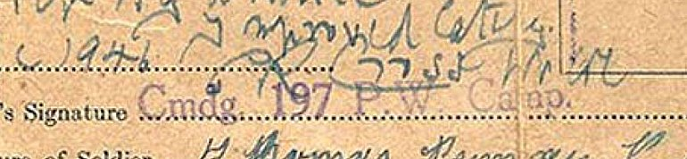  Part of Thomas Penman’s army record.  Does this show that this camp was out of use for pows by 1946, and in use as an extension to the military hospital? In June 1946 Thomas Penman was sent on to a Military Dispersal Unit in York.  A satellite camp was recorded as the ‘Drill Hall’ Hostel, Hill Street, Ross-on-Wye up to mid-1946 when it was transferred to camp 61. Conditions there were recorded by the ICRC as being ‘primitive’.  There was also a camp at ‘Bulwark’ in Chepstow, but this is not in the same area – maybe a satellite camp? | 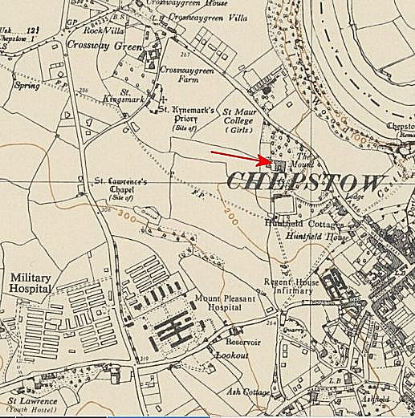
 | Ordnance Survey 1955

After the camp: Boarding school. Grade II listed building. 2020 residential.

Further Information:

National Archives

Details of Thomas Penman - camp59survivors.com/2016/04/06/thomas-penman/

