Camp 196 Arbury Hall, Nuneaton, Warwickshire

1947 Camp List
196(G.W.C.) | Arbury Hall Camp, Nuneaton, Warwickshire | N. | Nuneaton | Nuneaton 3421 | Nuneaton | Lt.Col.F.G.Holbrook, R.A. | v/1453/2

Prisoner of War Camps (1939 – 1948) - Project report by Roger J.C. Thomas - English Heritage 2003
OS NGR | Sheet | No. | Name & Location | County | Cond’n | Type 1945 | Comments
SP 334 894 | 151 | 196 | Arbury Hall, Nuneaton | Warwickshire | 4 | Base Camp | Restored parkland.

Location: To the SE of Nuneaton  Before the camp: Large country hall and estate. British and American troops were stationed in the parkland.  Pow Camp:  Memories – “It was while I was there that I met the Yanks when they arrived and set up a camp on the estate. When they left it was replaced by a German prisoner of war camp. The German prisoners went on to rebuild the bombed church at Chilvers Coton in Nuneaton.” BBC People’s War website, story by Anthony Harris, Article A8997105, 20 January 2006).  Camp commandant c1947 Lieutenant Colonel F G Holbrook, R.A. From the Royal Artillery. Varied service record including 1924 as 1st Assistant Chief Technical Officer at the Chemical Warfare Experimental Station at Porton. By 1932 an instructor with the Royal Tank Corps School.  After the camp: Parkland restored.  Further Information: |  |  | 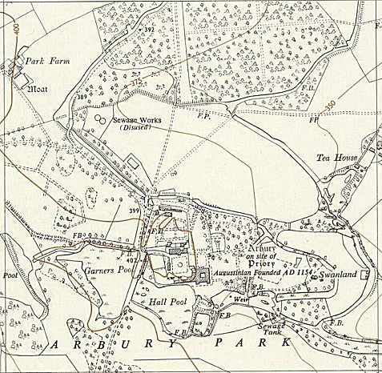
 |  |  | Ordnance Survey 1955
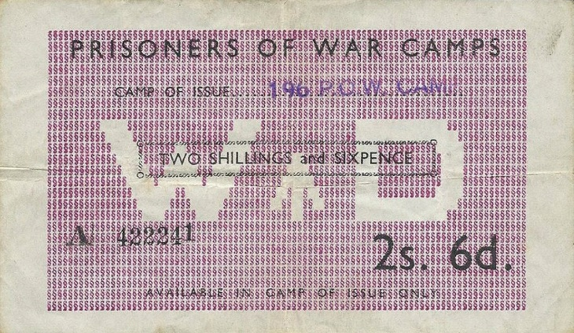 | 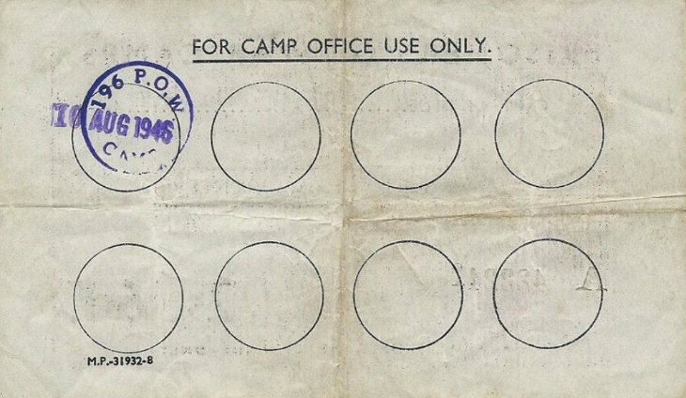 | Money’ for use in Camp 196 only – dated 10 August 1946

