Camp 195 (& 241) Merevale Hall Camp, Atherstone, Warwickshire

1947 Camp List
241(G.W.C.) | Merivale Hall Camp, Atherstone, Warwickshire | N | Priswar, Atherstone | Atherstone 3245 | Atherstone | Lt.Col.A.J.Godfrey | v/1453/2

Prisoner of War Camps (1939 – 1948) - Project report by Roger J.C. Thomas - English Heritage 2003
OS NGR | Sheet | No. | Name & Location | County | Cond’n | Type 1945 | Comments
SP 299 980 | 140 | 195 | Merevale Hall Camp, Atherstone | Warwickshire | 4 | Base Camp | Restored parkland. See Camp no.241
 |  | 241 |  |  |  | German Working Camp

Location: Merevale Hall is near Atherstone.  Before the camp: Country house and estate.  Pow Camp: Pictures in the Wright Family Rural North Warwickshire Archive show Italian and German pows.  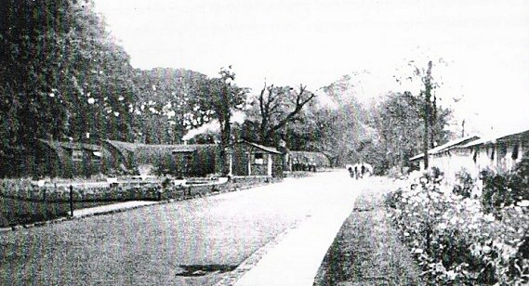  < The main avenue of Merevale camp. August 1946.  (The picture was from the ‘Ourwarwickshire’ website which no longer opens. It was not listed as coming from the Wright Family Collection). It shows a mixture of Nissen type and other construction for the huts.  A brief description of the camp is included in diary extracts from Vinzenz Fetzer, (Tonbridge Historical Society), a German POW who was held at Merevale Camp from 25 October 1944 until 10 March 1945.  “I wrote fewer notes there, as there was a dearth of paper and pencils. The camp was big and in an old park. A | 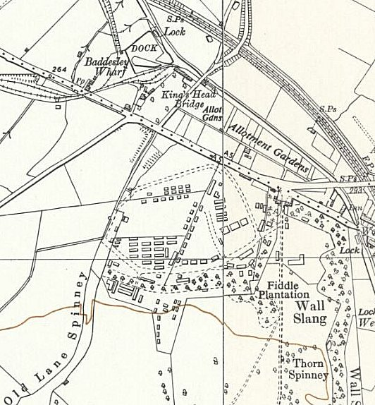
 | Ordnance Survey 1955
walk around the barbed wire perimeter fence took half an hour. I didn't do any work there and completely gave up smoking. Our rations were very good, sufficient and varied. In the first four weeks things were a bit short until everything was up and running…… Many courses took place which I attended. I also sang in the choir and was never bored. RC and Protestant services were held but with only 15% attendance.” He later moved to camp 194, Penkridge and camp 40, Somerhill.

Camp commandant c1947 Lieutenant Colonel A J Godfrey. (I think he was from the Royal Artillery).

After the camp: Private country house and estate.
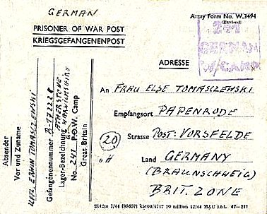 | < Pow postcard dated July 1946  Further Information:

