Camp 194 Teddesley Hall Camp, Penkridge, Staffordshire

Prisoner of War Camps (1939 – 1948) - Project report by Roger J.C. Thomas - English Heritage 2003
OS NGR | Sheet | No. | Name & Location | County | Cond’n | Type 1945 | Comments
SJ 947 157 | 127 | 194 | Teddesley Hall Camp, Penkridge | Staffordshire | 5 | Base Camp

NOTE – some of the details for the two camps 194 in Penkridge are confused, e.g. an escape by 13 pows is listed for both camps.  Location:  Before the camp: A large Georgian English country house and estate. Requisitioned at the start of the war for troop training. Troops included the US army as there is a photograph of a ‘Capt Frank W Kazmer giving address to his troops. He was a company commander of Combat Engineers’ – the Hall can be seen behind him. There is an entry for the History of the 446th quartermaster troop transport company that they were also located at Teddesley from 5 April 1944 to 18 May 1944.  Pow Camp:  Possible escape from this camp – see under Council Houses Camp 194  The camp had its own weekly newspaper – ‘Der Ruf: Antifaschistische Wocnenzeitunf Camp 194’ (The Call: Anti-fascist weekly news).  Near to Camp 194 Council House Camp, Penkridge  After the camp: The Hall was demolished in 1954.  Further Information:  National Archives FO 939/179 – 194 Working Camp, Teddesley hall Camp, Penkridge, Staffordshire. Dated 1945-1948.  IWM have copies of the camp newspaper January – March 1947. Catalogue LBY E.J. 411 | 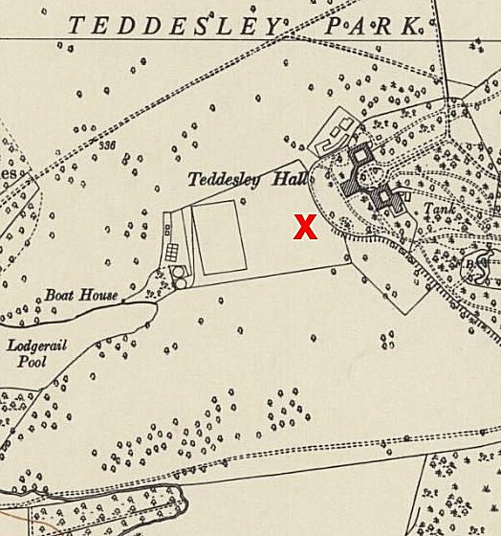
 | Ordnance Survey 1954

