Camp 194 Council Houses Camp, Penkridge, Staffordshire

1947 Camp List
194((G.W.C.) | Council Houses Camp, Penkridge, Stafford | W. | Priswar, Penkridge | Penkridge 343 | Penkridge | Lt.Col.R.F.J. Hayward, V.C. | v/1453/2

Prisoner of War Camps (1939 – 1948) - Project report by Roger J.C. Thomas - English Heritage 2003
OS NGR | Sheet | No. | Name & Location | County | Cond’n | Type 1945 | Comments
SJ 92 13 | 127 | 194 | Council Houses Camp, Penkridge | Staffordshire | 5 | Base Camp | Precise location not identified, NGR given for centre of village

NOTE – some of the details for the two camps 194 in Penkridge are confused, e.g. an escape by 13 pows is listed for both camps on different sites/books.  Location: Penkridge is 8km S of Stafford, 15km N of Wolverhampton. There is a likely site in square SJ 92 14. Two histories of the area record that there was a military camp on the old common lands, called The Marsh, between the River Penk and Cannock Road. Neither mention a pow camp here or anywhere else, but go on to say that a large council housing estate was built there. This site is on the 1954 map where various buildings (huts / new housing?) are shown at The Marsh on the right.  Before the camp:  Pow Camp:  Near to Camp 194 Teddesley Hall Camp, Penkridge. This Council House Camp is included in the 1947 camp list, while the Teddesley Hall camp is not. Both are mentioned as base camps in the 2003 English Heritage report. It is likely therefore, that Teddesley existed up to 1945, then during that year it closed, and the Council House Camp opened.  NOTE CONFUSED LOCATION for the following entry. This is recorded by the Island Farm Camp website for the Council Houses Camp –  “13 POWs cut the wire in very foggy conditions. As soon as they were free they split up into small parties. But two were caught in Wolverhampton, two in Walsall, two in Derby, 4 single-handedly by a police office who tricked them in to believing he was taking them to get a lift when their stolen car ran out of petrol and two in Liverpool. The thirteenth man, whose believed intention was to head for Liverpool and stow aboard a ship, was never returned to the camp and today it is not clear whether this officer succeeded in getting away.  A later tunnel was suspected but couldn't be located by guards until the secret was eventually deliberately given away (under a bed in Hut 4) by the German camp choirmaster. The planned | 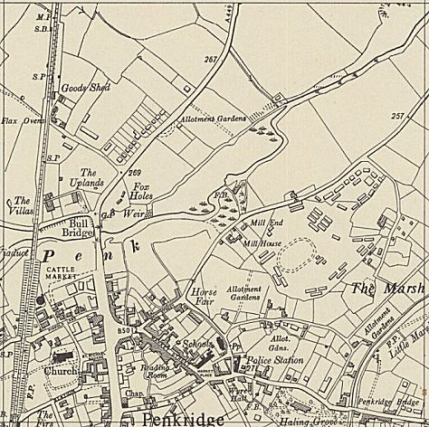
 | Ordnance Survey 1954
break out was to have been for 100+ POWs. The nerve of the choirmaster cracked under the pressure / fear of being found out and was making his way rather hurriedly towards the gates. He was spotted and after a short chase he made it through the gates and was transferred to another camp for his safety!”

However, the book ‘Stafford at War 1939 – 1945’ states the event happened on 18 December 1944 at Teddesley pow camp. (Nick Thomas, 2009, Pen and Sword books).

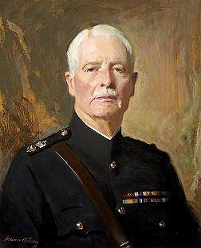 | Assuming my dating is correct, this camp was raised in the House of Commons in 1948;  “Mr. Swingler asked the Minister of Agriculture why B/41758 P.o.w. Ernst Wedding of 194 P.o.w. Camp, Penkridge, Stafford, has been refused a permit for employment as a market gardener by the Staffordshire Agricultural Executive Committee; whether he is aware that this volunteer was offered a post with accommodation; and if he will take immediate steps to grant authority for his employment, in view of the fact that he is due for repatriation on 9th April.  Mr. G. Brown - Wedding applied for employment with the Staffordshire Agricultural Executive Committee, but was rejected in favour of more suitable applicants. I also understand that he offered his services to a market gardener who, ​ however, does not wish to employ him. In these circumstances I am not arranging for his retention.” (Written answers – House of Commons - 25 March 1948, Vol 448).  Mr Swingler asked the same question in debate on 12 April 1948.  Camp commandant Lieutenant Colonel Reginald Frederick Johnson Hayward V.C. and M.C. (1891 – 1978).  After the camp: Residential area.  Further Information:  Details of the VC awarded to Lt.Col Hayward – www.thegazette.co.uk/London/issue/30648/supplement/4967  There are several histories available online.  < Lieutenant Colonel Reginald Frederick Johnson Hayward

