Camp 193 Madeley Tile Works Camp, Madeley, Cheshire

Prisoner of War Camps (1939 – 1948) - Project report by Roger J.C. Thomas - English Heritage 2003
OS NGR | Sheet | No. | Name & Location | County | Cond’n | Type 1945 | Comments
SJ 787 452 | 118 | 193 | Madeley Tile Works Camp, Madleley, Crewe | Cheshire | 5 | Base Camp | Precise location not identified, NGR given for tile / brick works. A further works is located at SJ 775 438

Location: Madeley is 8.0 km W of Newcastle-under-Lyme. The site is in Staffordshire. The first NGR above is shown at ‘X’. The Madeley website and local history state that the camp was at the Dignus Tile Factory which was located ‘down Honeywall Lane’ near to the ‘Keele Tileries’ on the map.  Before the camp:  Pow Camp: There are some accounts of Italian pows being held here before Germans.  One of the German pows at the camp was Wilhelm Rubenbauer, (1916-1993). From Wilhelm Rubenbauer’s biography; “He went to school to learn about hand painted glass and porcelain... He was captured shortly before the end of the Second World War and spent the next four years imprisoned in an old brickyard in England where there were approximately 1500 to 2000 German fellow prisoners.  In the first days they were not allowed to work, so boredom set in. While there, it drew this soldier again to his old passion, painting. Lying around were cement bags that when soaked in water, torn up into small pieces and pulled over heating pipes to remove any creases could be used to produce artwork. Now there was something to fill out the long wait, motion studies and sketches from the camp life. |  | 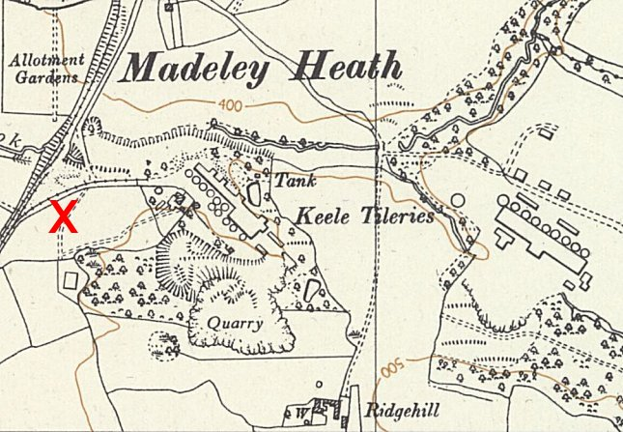
 |  | Ordnance Survey 1954
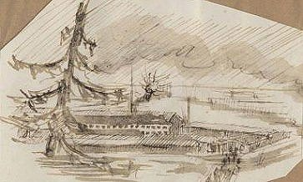 | Sketch of Camp 193 by Wilhelm Rubenbauer  Photograph of the Dignus tileries  Christmas 1944. Six paint boxes with six colours in each are distributed to the imprisoned soldiers by the Red Cross. Willi Rubenbauer is lucky enough to receive one of them. He makes good use of it.”  He later moved to Adderley Hall Camp 192. |  | 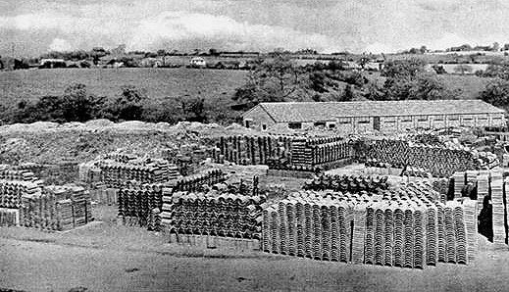

After the camp:

Further Information:

http://www.madeleyvillage.co.uk/wilhelm-rubenbauer-at-the-pow-camp/

