Camp 192 Adderley Hall, Adderley, Shropshire

Prisoner of War Camps (1939 – 1948) - Project report by Roger J.C. Thomas - English Heritage 2003
OS NGR | Sheet | No. | Name & Location | County | Cond’n | Type 1945 | Comments
SJ 657 401 | 118 | 192 | Adderley Hall, Adderley, Market Drayton | Shropshire | 4 | Base Camp

Location: Adderley Hall was near Market Drayton in Shropshire. The camp was probably located in the grounds, rather than in the house.  Before the camp: Shropshire Council HER: “WWII reinforcement camp to be occupied by 3 Corps in the event of an invasion of the UK. Capacity 1,000 personnel. Also known to be occupied by black American soldiers”.  Pow Camp: Shropshire Council HER: “..used as a Italian POW Camp… An interesting feature of the stable block (PRN 19242) is a carved inscription in gothic script on the trusses of the single storey building attached to the stable block - Truth will set you free - in German, associated with the use of the parkland at the hall as a Prisoner of War camp in WW2.”  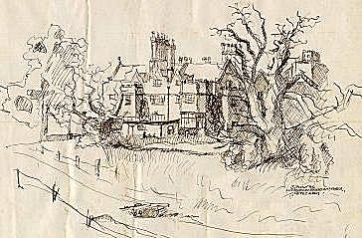  One of the German pows held at the camp was the artist Wilhelm Rubenbauer (1916-1993). He drew the picture of the hall, dated 3 June 1946. (He was also at Camp 193).  After the camp: The Hall was demolished in 1955  Further Information:  Field survey report: King M J. 2004. Listed building conservation statement…The Stable Block and adjacent farm buildings at Adderley Hall Farm, Adderley in the county of Shropshire. King Partnership Rep. p.3. | 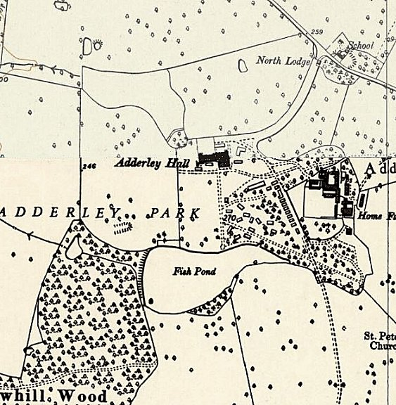
 | Ordnance Survey 1954

