Camp 187 (& 404) Ivybridge Camp, Ivybridge, Devon

Prisoner of War Camps (1939 – 1948) - Project report by Roger J.C. Thomas - English Heritage 2003
OS NGR | Sheet | No. | Name & Location | County | Cond’n | Type 1945 | Comments
SX 642 564 | 202 | 187 | Ivybridge Camp, Ivybridge | Devon | 4 |  | Site occupied by housing and schools. See Camp no.187 / 404.
 |  | 404 |  |  |  | Base Camp

Location: Ivybridge is on the S edge of Dartmoor.  Before the camp:  Pow Camp:  After the camp: 2020 residential area and school.  Further Information: | 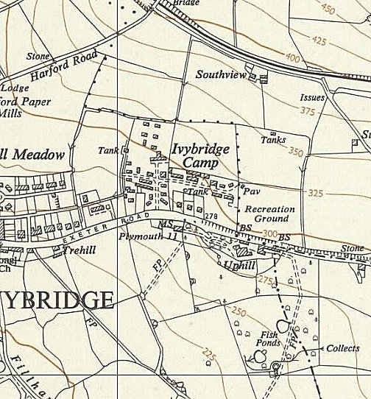
 | Ordnance Survey 1954

