Camp 187 Dungannon, County Tyrone

Prisoner of War Camps (1939 – 1948) - Project report by Roger J.C. Thomas - English Heritage 2003
OS NGR | Sheet | No. | Name & Location | County | Cond’n | Type 1945 | Comments
 |  | 187 | Dungannon | County Tyrone |  |  | Northern Ireland

Location: There is a Pinterest picture showing a small row of buildings which remain of what was once the Ballynorthland Prisoner Of War Camp in Dungannon.  The only other reference I have to location is that it was in ‘The Park’ – which could be Dungannon Park shown on the map.  Before the camp: The 3d Field Artillery Observation Battalion of the United States Army were based at Ballynorthland for a short time – this could be the site for the pow camp..  Pow Camp:  There was a reprint of a news article in The Irish News – unfortunately it did not have a date:  “While attempting to escape from a prisoner of war camp near Dungannon, Co Tyrone on Monday night, a German prisoner of war, aged 21, was fired on by the military guard and received five bullet wounds.  He was attended by two German doctors and by Dr J G Bell of Dungannon and was later removed to a military hospital in Belfast in a serious condition.  It is stated that the German had got clear of the heavy barbed wire entanglements when spotted, and as he refused to halt, the sentry opened fire.  He received four bullet wounds in the right arm and the fifth in the chest. The right arm was badly shattered and Dr Bell had to give a blood transfusion.”  After the camp:  Further Information: | 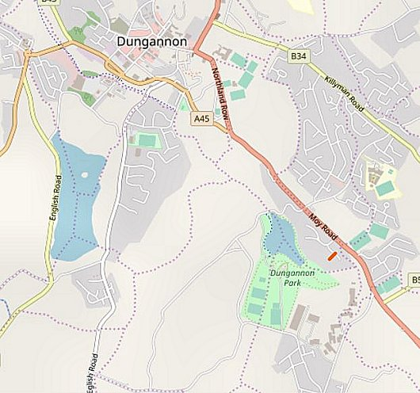
 | © OpenStreetMap contributors

