Camp 186 Fornham Park Camp, Bury St Edmunds, Suffolk

1947 Camp List
186(B.C.) | Berechurch Hill Camp, Colchester, Essex | E. | Priswar, Colchester | Colchester 4275/6/7 | Colchester | Lt.Col.R.F.Squibb M.C. | v/202/4
The entry above has been crossed out in blue crayon and the following details handwritten on.
 | Fornham Park, Bury St Edmunds, Suffolk |  | Priscamp, Bury St. Edmunds | Bury St Edmunds 2322 | Bury St. Edmunds | J.F.Ashton | v/202/5

Location: NGR for Fornham Hall TL 841 684. A large number of huts can be seen dotted about all over Fornham Park.  Before the camp: Country Hall and Estate. In late 1939 Fornham Park and Hall were requisitioned by the War Department for troops.  By 1947 the camp had been empty for well over a year and was in bad repair. The waste of space and money was raised in the House of Commons by Geoffrey Clifton-Brown, the MP for Bury St. Edmunds. (Hansard Commons - 13 March 1947, Vol 434).  Just two months later he raised the site again;  “Lieut.-Colonel Geoffrey Clifton-Brown asked the Secretary of State for War why it has become necessary to recondition and re-equip Fornham Park Camp, Bury St. Edmund's, which has stood derelict for 18 months; what will be the cost of this work; and if there is no barrack or permanent camp more suitable for peace-time military occupation.  Mr. Bellenger - Fornham Park Camp, Bury St. Edmunds is being reconditioned and re-equipped to accommodate a regiment returning from overseas. The camp was evacuated approximately six months ago by Polish Forces when it was certainly not in a derelict condition. The cost of the work being carried out is estimated at £700, and there is no more suitable barrack or permanent camp available at present for the purpose for which it is required.” (Hansard - 6 May 1947 - Vol 437).  This response was challenged as there was no knowledge of Polish troops at this site, the site was empty and was certainly in a bad state up until the time of reconditioning. There was then a change of mind for the purpose of the camp as it became a camp to hold pows being repatriated from Harwich.  Pow Camp: The camp was open from 1947 to 1948. It was allocated number 186 as Berechurch was closed down. At least some of the pows were transferred from Berechurch to Fornham. | 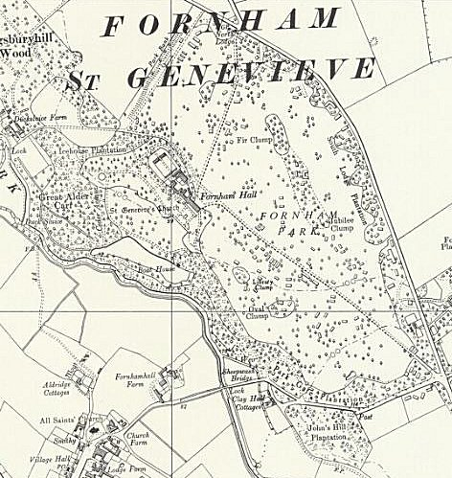
 | Ordnance Survey 1957
Posted on the Axis History Forum :-
"SS Hauptsturmführer Franz Schwinghammer - After the war POW in Naples, London District Cage, Berechurch Hall (Colchester) and Fornham Park (Bury St. Edmunds). POW 209166. Returned to Austria in 1948." (I obtained this information from the St Edmundsbury Chronicle website – see below).

One German pow committed suicide, hanging himself in the woods at the camp. It was believed that he feared being sent home to the Russian sector of Germany.

Camp commandant Lieutenant Colonel John Forbes Ashton, from the Border Regiment.

Fornham Park was recorded as the last pow camp to close.

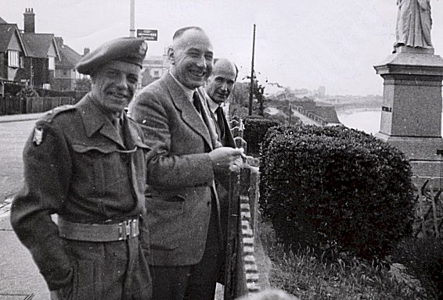 | 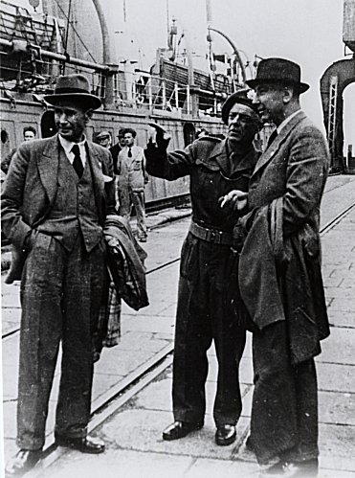 | 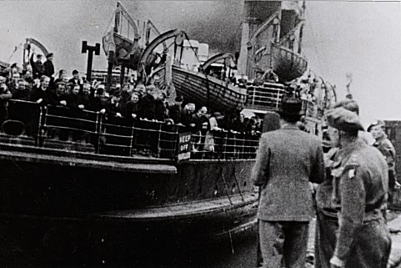
1948 Caption for Photographs – ‘Dernier rapatriement de prisonniers de guerre allemands’ – The last repatriation of German Prisoners of War – ICRC Archive

The pictures above were taken in Harwich, dated 12 July 1948.

In picture 1, from left to right; Lieutenant Colonel J F Ashton, camp commandant; Frédérick Bieri, ICRC delegate; and Jean Muller, ICRC delegate. Frédérick Bieri was the lead delegate and wrote many of the pow camp reports for the ICRC.

Pictures 2 and 3, the same men at the port. The ship was the SS Biarritz.

Postal items: Pow letter-sheet December 1947 / envelope with camp single ring stamp May 1948.

After the camp: The Hall was demolished in 1951

Further Information:

stedmundsburychronicle.co.uk/fornhampark/fornhampark.htm

