Camp 186 Berechurch Hall Camp, Colchester, Essex

1947 Camp List
186(B.C.) | Berechurch Hill Camp, Colchester, Essex | E. | Priswar, Colchester | Colchester 4275/6/7 | Colchester | Lt.Col.R.F.Squibb M.C. | v/202/4
The entry above has been crossed out in blue crayon and the following details handwritten on.
 | Fornham Park, Bury St Edmunds, Suffolk |  | Priscamp, Bury St. Edmunds | Bury St Edmunds 2322 | Bury St. Edmunds | J.F.Ashton | v/202/5

Prisoner of War Camps (1939 – 1948) - Project report by Roger J.C. Thomas - English Heritage 2003
OS NGR | Sheet | No. | Name & Location | County | Cond’n | Type 1945 | Comments
TL 994 217 | 168 | 186 | Berechurch Hall Camp, Colchester | Essex | 3 | Base camp | Large complex of huts within a double wire perimeter fence. Large number of  huts have been demolished and replaced by modern accommodation.

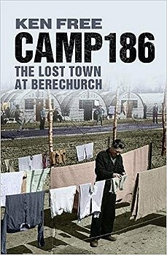  There is an excellent, detailed book about Berechurch Camp. I therefore only give very brief details and some additional details here.  ‘Camp 186; The Lost Town At Berechurch’ –Ken Free –2010 –Amberley  Book Review – “..Camp 186 held 6,000 mostly 'other ranks' - ordinary Germans who had been forced into an abnormal situation. Home to extreme Nazis and to strong pacifists they formed a volatile mixture. Largely using original articles and letters by the prisoners, it tells some of their stories, from capture to arriving at night in a desolate field. Living in bell tents and despite the bitterly cold winter and quagmire that formed, they created a hospital and theatres with a programme of which any professional company would be proud. Despite the hatred and murders, they broke down the barriers of religion and even became home to a Catholic Seminary. The camp boasts what is probably the largest number of successful escapees in one attempt, but also the story of a prisoner who escaped but came back a year later - a case described by the Head of the British PoW Investigation Department as 'the most improbable story'.”  The camp opened for German pows in September 1944. Parts of the site may have been constructed / adapted by Italian pows before this. Camp closed in 1947.  Some Spanish pows who were on their way to other camps, (mainly Chorley) were held here briefly in 1945. Even though they had been forced to work for the Germans, and many were anti-fascists, because they were captured in France wearing German uniforms, the army had no choice but to regard them as pows. (See ‘We Also Stood Alone’ – E J Castro – 1945). | 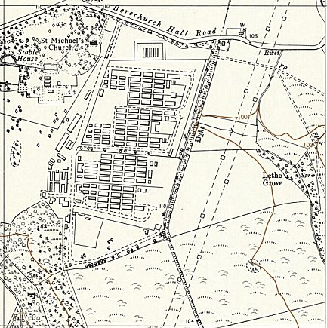
 | Ordnance Survey 1958

Camp commandant c1947 Lieutenant Colonel Reginald Frederick Squibb M.C. He served with the Loyal Regiment (North Lancashire) up until 1943 when he transferred to the Pioneer Corps.

[There is a book about the site after it was a pow camp – ‘Colchester Military Corrective Training Centre’ by C McEntee-Taylor – I have not read this].

