Camp 185 Springhill Lodge Camp, Blockley, Gloucestershire

1947 Camp List
185(G.W.C.) | Springhill Lodge Camp, Blockley, Moreton-in-Marsh, Glos | S. | Priswar, Blockley | Broadway 252 | Moreton-in-Marsh | Lt.Col.J.Hassell, D.S.O. M.C. | v/1453/2

Prisoner of War Camps (1939 – 1948) - Project report by Roger J.C. Thomas - English Heritage 2003
OS NGR | Sheet | No. | Name & Location | County | Cond’n | Type 1945 | Comments
SP 132 357 | 151 | 185 | Springhill Lodge Camp, Five Mile Drive, Blockley | Gloucestershire | 1 | Base Camp | Large complex of huts within a roughly octagonal double wire perimeter fence guarded by watchtowers

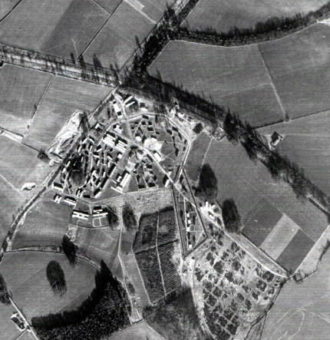 | 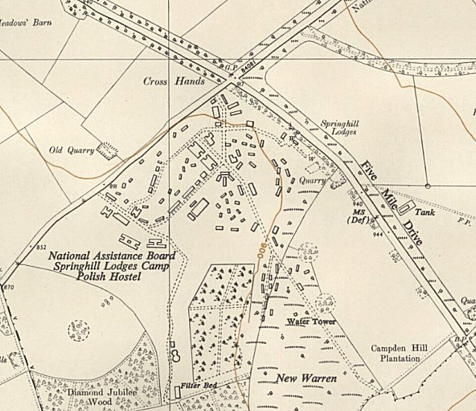
Aerial view of Springhill camp from 1947 | Ordnance Survey 1955

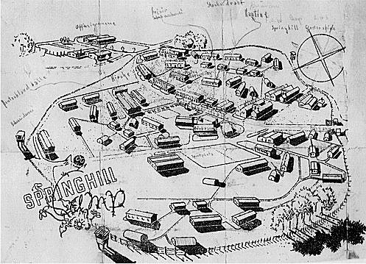 | Picture plan of the camp produced by a German pow. With thanks to Chipping Campden History Society, (see website details below).  NOTE: There is an excellent chapter about Camp 185 in Ian Hollingsbee’s book. I therefore only give a summary and a few further details here.  Before the camp: Built as workers’ accommodation in 1937. Used for British military accommodation from the start of the war, possibly also US troops up to D-day.  Pow Camp: Opened as a pow Base Camp in September 1944 - described shortly after by the International Committee of the Red Cross (ICRC) as, “one of the best fitted out we have visited”. The camp was expanded during its time and accommodation was in Nissen huts, wooden huts and brick-built buildings. Capacity was stated to be 7,500, but the highest number reached was 2,350 when it opened.  The first pows were mixed nationalities – 1140 Germans, 1200 Polish, 7 Dutch, 1 French, 1 Lithuanian, 1 Turk. 2 camp leaders, 1 German and 1 Polish are recorded in the first ICRC report. Mixed nationality camps were seen as difficult to manage and in the next report only German pows were recorded. Pows were considered to be low-risk.

An ex-guard stated that there were a few escape attempts, but they were not overly serious, and all were quickly recaptured.  The ICRC report from June 1946 records 200 pows arriving from camps in Belgium in a severe state of malnutrition. 2 of these pows died in transit to hospital, 2 more died in the camp’s infirmary. 1 suicide was also noted.  The camp status changed from a Base Camp to a Working Camp in October 1946.  The camp was inspected by the ICRC on 25 October 1944, 25 April 1945, 23 January 1946 (2134 pows), 15 June 1946, 1 June 1947 (1872 pows main and hostels), 10 November 1947 (1186 pows – 673 main camp).  Camp commandant c1946 / 1947 Lieutenant Colonel J Hassell, D.S.O. M.C.  Camp comandant 1947 Lieutenant Colonel J P Fowler-Esson, from the Hampshire Regiment.  Five hostels: (there were also billets)  Over Norton – 228 pows, June 1947 – 185, November 1947.  Burford – 50, June 1947 – closed by November 1947.  Stanton – 203, June 1947 – 45, November 1947.  Condicote – 123, June 1947 - 181, November 1947.  Horley - 39, June 1947 | 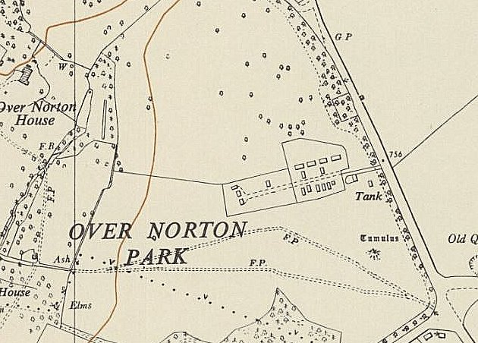
 | Ordnance Survey 1955 - Over Norton – SP 324 285

Camp 37 at Sudeley was administered by Camp 185 during 1947.

The camp closed 31 January 1948

After the camp: Became a Polish settlement administered by the National Assistance Board. 2019 the latest OS map still shows ‘Camp (dis)’.

Further Information:

www.chippingcampdenhistory.org.uk/wp-search/springhill

Inside the Wire – Ian Hollingsbee - 2014 – The History Press.

