Camp 183 Beckton Marshes Camp, East Ham, London E6

Prisoner of War Camps (1939 – 1948) - Project report by Roger J.C. Thomas - English Heritage 2003
OS NGR | Sheet | No. | Name & Location | County | Cond’n | Type 1945 | Comments
TQ 439 809 | 177 | 183 | Beckton Marshes camp, East Ham, London E6 | London | 5 |  | Precise location not identified, NGR given for marshes

Location: The NGR above is shown at ‘X’, but listed as not identified. Beckton is a suburban district in East London, England, within the London Borough of Newham and is located 8 miles (12.9 km) east of Charing Cross.  Information from ww2talk.com/ - the site may have been at ‘T5’, one of the ‘T Marshalling sub-areas’ for D-day. The location of T5 makes this seem highly likely.  Before the camp:  Pow Camp:  After the camp:  Further Information: | 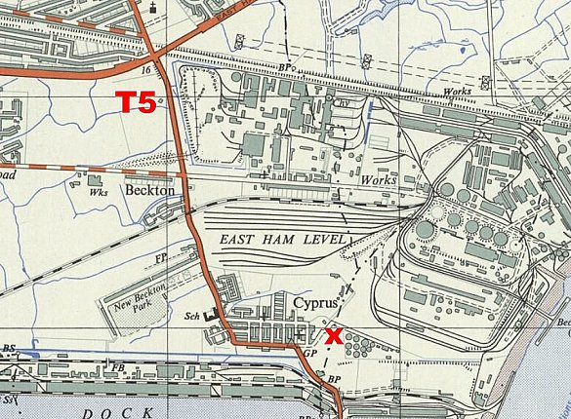
 | Ordnance Survey 1956

