Camp 182 (& 298) Barony Camp, Parkgate, Dumfries

1947 Camp List
298(G.W.C.) | The Barony Camp, Dumfries | Sc | Priswar, Parkgate, Dumfriesshire | Parkgate 237/8 | Shield Hill Dumfries (L.M.S.) | Lt.Col.G.Murray | v/1453/2

Prisoner of War Camps (1939 – 1948) - Project report by Roger J.C. Thomas - English Heritage 2003
OS NGR | Sheet | No. | Name & Location | County | Cond’n | Type 1945 | Comments
 |  | 182 | Barony Camp | Dumfries |  | Base Camp | Scotland

Location: NGR NY 018 872. Camps 182 and 298 at Barony, Parkgate, Dumfriesshire were on either side of the Parkgate Road. Camp 182 is now the location of Barony Agricultural College while 298 is derelict and the remains of several huts are still to be seen.  There seems to have been a main camp and a smaller collection of huts as an annexe. If this is the case, I would think the dual site was regarded as a single camp, with one number and one commandant at any one time. The number seems to have changed when the camp changed from a Base camp to a Working Camp.  Before the camp: Galbraith family estate. Taken over for military purposes at the start of WW2.  Pow Camp: “Visible on the air photographs is the perimeter fence and an extension enclosure. The camp is situated mainly to the NW of the house with the possible staff quarters to the NE. The main section of the camp consisting of at least 90 huts, mainly of the Nissen type lies about 250m SE of the main entrance to the estate at Parkgate. Further groups of huts can be seen of the photographs in an area immediately N of the main house.” Information from RCAHMS (DE), July 2005.  From Secret Scotland Website – “Captured German soldiers of the 553 Division 1120 Grenadier Regiment were transported and housed at Camp 182, vetted then moved on to other working camps throughout Scotland.  Although not listed in 1948 as one of the main holding camps for Ukrainian members of the Waffen-SS Division Galizien, I have seen a report that some were held at this camp.  The camp had its own magazine, one of the rare ones that used colour – ‘Litfaßsäule’ (Advertising Column). | 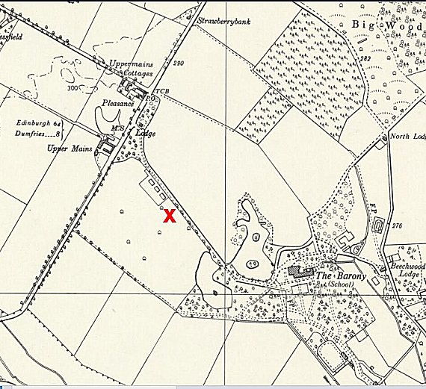
 | Ordnance Survey 1955
Camp commandant c1947 Lieutenant Colonel G Murray

After the camp: The main group of huts at X were removed after the camp was closed and the Ordnance Survey maps show that a small housing estate has been built on the northern part and annotated 'Beech Avenue'. 2019 The Barony is shown as a college

Further Information:

National Archives FO 939/184 – 298 Working Camp, Barony Camp, Dumfriesshire. Dated 1945 – 1948.

Air photograph (541 [A] 397, 3157-3158, flown 20 May 1948

