Camp 181 (& 249) Carburton, Worksop, Youngrough Breck, Nottinghamshire

1947 Camp List
249(G.W.C.) | Carburton Camp, Worksop, Notts | N. | Priscamp, Worksop | Worksop, 2816 | Worksop | Major J.E.Johnson | v/1452/2

Prisoner of War Camps (1939 – 1948) - Project report by Roger J.C. Thomas - English Heritage 2003
OS NGR | Sheet | No. | Name & Location | County | Cond’n | Type 1945 | Comments
SK 602 732 | 120 | 181 | Carburton Camp, Youngrough Breck,  Worksop | Nottinghamshire | 4 | Base Camp | Large complex of huts within a double wire perimeter fence guarded by watchtowers. See Camp no.249.

Location:  Before the camp: The area was used by the military including Canadian troops up to D-day.  Pow Camp: This was first numbered camp 181, and then 249.  On opening, the camp was intended to hold NCO’s and other ranks with a capacity of approximately 1,400. A small number of officers were present as medical staff, dentist and padres. There was a medical centre, offices, cookhouse, latrines, showers and huts used for classrooms.  Henry Faulk was the camp interpreter and achieved noteworthy respect and success. He stated; “I told them what I thought and said I was prepared to discuss what they thought – as a basis for looking into the future.”* Subsequently, when the War Office made a request for German pows to work on farms, all of the pows at Carburton volunteered, while there had been total refusal in other Midland camps.  Following an escape at Bridgend Camp 11 (198), on 10 March 1944 by 70 German officer pows, it was decided that this camp would be changed to a high security camp for the ‘ardent’ Nazi officers.  Most of the existing pows were transferred to other camps. Henry Faulk was allowed to interview and select 250 pows, including 5 officers (a dentist, two doctors, and two padres), of the existing number to stay on at the camp as staff. | 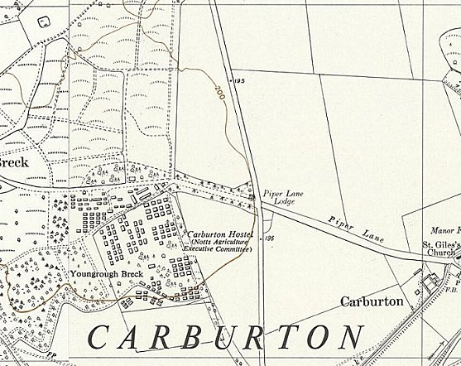
 | Ordnance Survey 1952
On 23 March 1945, more than 1,200 officers from Camp 11 arrived at Worksop Station in the evening. On the five-mile march to the camp they sang Nazi songs. It was dark and late by the time they arrived at the camp, and their reception did not go as planned. Faulk was at first regarded as a German traitor and was all-but ignored as the pows allocated themselves into huts that they had organised on the journey to suit their purpose of gaining control. The senior officer, Colonel Lemke moved into a hut in the centre of the camp, while the real political controlling officer, the Adjutant, (reported to be ex Gestapo) moved into a hut alongside.

The nature of many (not all), of the officers was soon revealed over the next ten days.

The camp chapel had been built, like many others, from scrounged materials and was of such quality that it had been visited by architects. A plot was hatched to tear down the cross and damage the building. Faulk had the chapel illuminated by car headlamps and posted sentries. Some of the officers then decided they would get into the chapel and desecrate it by using it is a toilet – this too was prevented by the guards.

At some time in late March, (different days recorded), Senior Officer Lemke and the Adjutant met with Commandant Ellison and Faulk. The Adjutant suggested that they should take over the administration of the camp, including the officers’ personal accounts and the issue of camp vouchers used to buy items in the camp canteen. Faulk was aware that they had used this method to maintain control in Camp 11, and refused.

Other more sinister events were plotted. Surprisingly, two of the officers transferred from Camp 11 were men who had been savagely beaten by their ‘fellow’ officers. They were both elderly railway officials who held officer rank. Their offence had been to send the issued pow postcards to their families, instead of sending them as goodwill messages to Hitler on his birthday. At Carburton, one had been sent straight to the medical centre, the other requested ‘asylum’ with the trusted other ranks. The Adjutant requested that the man held with the ORs be returned so that he could be with his fellow officers. Faulk was warned that the man would likely be murdered, and refused the request.

There were attempts made to take control of the medical centre. Fourteen of the officers were doctors, and some of these demanded to take over from the existing two trusted officer doctors. This was refused under terms laid out by the Geneva Convention, as the two doctors were under orders of the holding power. Next, a very large sick parade was organised to prove more doctors were needed. It seems that the two doctors issued laxative pills to the queue of pows. A further attempt was then made with six large officer pows presenting themselves with fake symptoms requiring treatment. Again, Faulk was warned that their intentions were to wreck the centre and beat up some of the patients. He arranged to have them sent to a military hospital where they were kept under observation and a strict diet for six days.

A murderous plot was hatched against the Catholic chaplain, Father Lotz. A kangaroo court (secret court – Fehmgericht) was held and the Father was condemned to death by hanging for treason. Becoming aware of this, Faulk requested Lotz remain in the camp and not show weakness to the extremists. There was a problem of not alerting the pows intent on murder that their secret had been revealed. Father Lotz remained in his hut which was boarded up and had bolts placed on the door from the inside. He was also supplied with a whistle in case his hut was attacked – the guards remained out of sight. Even with these precautions he had to have been a brave man. During the night he did blow the whistle, but the guards were unable to capture the attackers.

In an attempt to instil order, Faulk approached Senior Officer Lemke and demanded he take control of his men, or he would be held personally responsible. Lemke took note and called a parade where he informed them; “If these things go on, I will myself hand the culprits over to justice.”* There are no further records of Fehmgericht at the camp.

Whether some of officers took Lemke seriously, or were being defiant, there were two other incidents. In one, officers appearing in the kitchen and were famously confronted by a pow cook swinging a large iron ladle. In the other, officers entered the camp offices making threats, but were defied by a German clerk named Beck.

One German officer pow, Siegfried Bandelow, stated later that some of the incidents were created deliberately. They were aware that there were informers and out of boredom they issued false rumours. However, though it may be true that tall stories were invented to wind up the guards, a favourite pastime for many pows – the actions of individuals show there was a great deal of real intention. Many of the plots mirrored events at camp 11 and elsewhere.

During these events the officers suspected of causing trouble were listed by the camp staff. On 4 April 1945, 250 of the pows were removed and sent to the nearby camp at Norton Park (174). There were no further serious incidents recorded at Carburton.

Incidental information from a German theatre group journal held by the Deutsches Historisches Museum. The group toured pow camps around England during 1946. It recorded its visit to Carburton Camp, 249 on 18th & 19th October 1946. (Note use of 249 number)

From the rank of the Commandant and the War Establishment number for 1947, the camp must have decreased in size.

Camp commandants:
c1945 Lieutenant Colonel P J M Ellison, from the Grenadier Guards.
c1947 Major J E Johnson

People Associated with the Camp:

Henry Faulk. Camp interpreter with a degree in French and German. He spent a year in Germany in 1933 and witnessed some Nazi violence and control techniques. Served with the Cameron Highlanders and as an intelligence officer until 1943 when he was involved in a serious motorbike accident. He later worked in Gosford Camp 16 (Aberlady) as interpreter and then transferred to Wandsworth Camp before moving to Carburton. After Carburton, Henry Faulk was promoted and became the Chief Executive Field Officer of the POW Division at the Foreign Office. He developed and oversaw the re-education programme at pow camps.

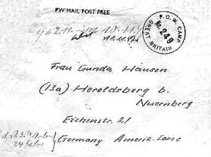 | Postal items: 1946 letter sheet as Camp 249  < Envelope 1947 (writing at top indicates late 1947) Camp 249  After the camp: 2020 woodland  Further Information:  * ‘Warriors Through The Landscape’ by the Battle of Hatfield Investigation Society, 2019. Excellent articles about Norton and Carburton Camps – freely available online 2019 –  battleofhatfieldsociety.co.uk/wp-content/uploads/2019/03/Book3-130219_compressed-1.pdf  Thresholds of Peace – M B Sullivan – Hamish Hamilton – 1979. (* 2 quotes above are from this book).  IWM - An interview with Henry Faulk about POW camps and his work –  www.iwm.org.uk/collections/item/object/80009528  ‘Group Captives: The Re-Education of German Prisoners of War 1945-48’ - Henry Faulk - Chatto & Windus – 1977. (He also wrote the 800p book – ‘Die deutschen Kriegsgefangenen in Grossbritannien’, Bielefeld, 1970).

