Camp 178 (& 247) - Ure Bank Camp, Ripon, Yorkshire

1947 Camp list
247(G.W.C.) | Urebank Camp, Ripon, Yorks | N. | Priswar, Ripon | Ripon 725 | Ripon | Lt.Col.L.D.Goddard | v/1453/2

Prisoner of War Camps (1939 – 1948) - Project report by Roger J.C. Thomas - English Heritage 2003
OS NGR | Sheet | No. | Name & Location | County | Cond’n | Type 1945 | Comments
SE 317 730 | 99 | 178 | Urebank Camp (Ure Bank), Ripon | Yorkshire | 4 | Base Camp | 101 huts of different types. Footings  paths etc remain extant. See Camp no.178 / 247
 |  | 247 |  |  |  | German working camp

Location: Just to the N of Rippon. The map shows the embankment placing the camp on higher ground next to the railway. Fields below this by the river were used for sports.  Before the camp:  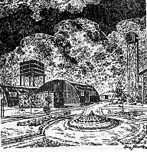  Pow Camp: First numbered 178, then 247.  The picture from the camp magazine shows Nissen type huts, a photograph of the Royal Engineers who used the camp just after the war also shows wooden huts. Some huts were used for the music / theatre groups – others were used for classrooms and workshops, e.g. Max Jäger set up a watch-making and repair workshop in hut 105, reported in the camp magazine, May 1947.  The camp magazine was called Die Pforte (Gateway).  The difficulties of providing education / training within the camp in 1945 were described – “At the instigation of the English interpreter, I then started various courses for the camp inmates with the help of one of the teachers and an assistant master: German grammar, English. Latin, history and arithmetic, including algebra. We naturally lacked textbooks. We also had no paper to write on. A couple of miserable pencils, some chalk and a blackboard were bought for us by the interpreter. The camp kitchen supplied us with a small quantity of paper in the shape of the wrappers from the milk tins. Interest in the courses died out when the POWs were moved nearer to their work on farms outside the camp.” (From ‘Prisoners of England’ by Miriam Kochan, 1980, Springer). | 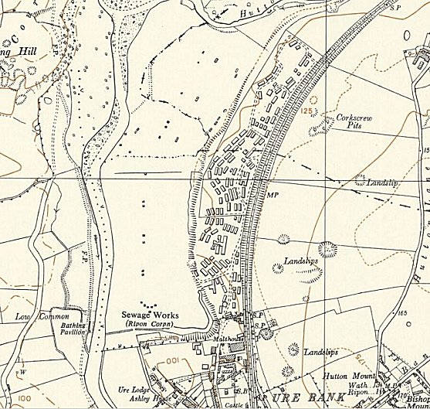
 | Ordnance Survey 1956

Camp Commandant c1946-1947 Lieutenant Colonel H McBain from the Durham Light Infantry – I am guessing this from the entry below for an invitation to a concert, (Durham records Office). Entry in the Supplement to The London Gazette – “Maj. H. McBain, O.B.E., M.C. (23000), having exceeded the age limit for retirement, is placed on ret. Pay, 23rd Sept. 1947, and is granted the hon. rank of Lt-Col.”

Camp commandant c.1947 Lieutenant Colonel L D Goddard (I think he was from the Royal Corps of Signals).

Postal items: As Camp 247: pow postcard October 1946 / 2 Letter-sheets from 1947 and 1948.

After the camp: 2019 mobile home and caravan site.

Further Information:

National Archives FO 1120/236 – Re-educational survey visit reports for camps 247 to 251. Dated 1 January 1946 – 31 December 1948

Durham Records Office – Ref D/DLI 7/426/14-18 relating to the Durham Light Infantry at Camp 247 – Programmes of music July & August 1946 / Menu for officers’ mess 31 July 1946 / Invitation from the pows at Camp 247 to Lieutenant Colonel H McBain to attend a concert, 14 September 1946

