Camp 174 - Norton Park Camp, Cuckney, Nottinghamshire

1947 Camp list
174(G.W.C.) | Norton Camp, Cuckney, Mansfield, Notts | N. | Priswar, Cuckney | Warsop 156 | Shirebrook or (special train) L.N.E.R. or L.M.S. Worksop. (L.N.E.R.) Normal traffic | Major A.E.Boughton | v/1452/2

Prisoner of War Camps (1939 – 1948) - Project report by Roger J.C. Thomas - English Heritage 2003
OS NGR | Sheet | No. | Name & Location | County | Cond’n | Type 1945 | Comments
SK 571 719 | 120 | 174 | Norton Camp, Cuckney, Mansfield | Nottinghamshire | 5 | Base Camp | Precise location not identified, NGR given for centre of village

There is a lot of information available about the camp from mid-1945 when it became a ‘study camp’ – a lot of it is freely available online.

Location: Square SK 57 72  Before the camp: Parkland  Pow Camp: One source stated that the camp was built in late 1942 and housed Italian pows – other sources state it was built for German pows including officers. There was a capacity of 400, housed in Nissen huts. About fifty Nissen huts were recorded at the camp, but some of these were used as classrooms. Many of the first German pows were ‘Black’, Category C Nazis. 250 extreme Nazis were transferred from Carburton Camp during early 1945.  In Autumn 1944, Swedish Pastor Birger Forrell proposed setting up a camp for pows to train as theological students. This received the support of the War Office and Winston Churchill. The idea was amended to include those wanting to take the Abitur (equivalent to ‘A Levels’) and train to become teachers.  By mid-1945, the existing pows were removed from the camp. Pastor Forrell, together with John Barwick, the American secretary in Britain of the World Alliance of YMCAs, established a study camp at Norton. (In some articles there are references to CVJM, the German form of YMCA). It was overseen by the International Red Cross Committee (ICRC). An opening ceremony was held on 8 August, led by Pastor Forrell giving a speech entitled, ‘The truth shall make you free.’  The camp had a motto – “Fide non armis” (Through faith not arms) which was put at the entrance to the camp.  The ICRC report for September 1945 records 30 officers and 262 other ranks. “Concerns were expressed as to the adequacy of the bed clothes for winter use and that the lighting and heating in the classrooms would have to be improved. The sanitary provisions were good with toilets and showers with hot and cold water and provision was made for each prisoner to take two hot baths. This was at a time when most local households regarded a weekly bath as the norm. Complaints were made about the food with 1,800 to 2,000 calories a day being provided for each man. The prisoners complained of constant hunger suffering from inability to concentrate, weakness | 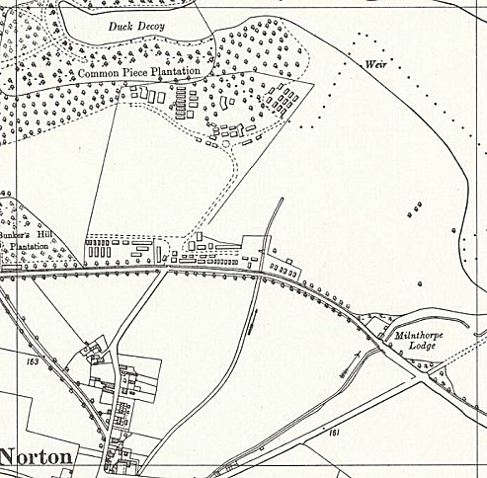
 | Ordnance Survey 1958
and giddiness and most had lost weight since entering the camp…. Medical services, under a German doctor and a German dentist were available for Norton and other camps on the Welbeck estate situated some 500 yards away from the camp including a dental section provided by the Americans who were also camped on the estate. The prisoners were issued with ‘battledress’ type clothing including two pairs of shoes and an overcoat. Although the ‘protected personnel’ and the teachers were paid, the students, at this stage, were not, although they were issued with toiletries and sweets from Y.M.C.A. funds... Both Protestants and Roman Catholics were able to participate in separate religious services with the Roman Catholic Chaplin at the nearly Carburton camp visiting to say the mass on Wednesday and Saturday. There was a large playing field on site to provide for leisure activities with a library of some 6,000 volumes including 1,200 novels, a camp cinema where a film was shown once a week, plus newspapers and radio access were available… the camp had its own orchestra. A total of 11 classes and 4 courses were already being taught with a further 80 prisoner/students due shortly.”

Extract from ‘Warriors Through The Landscape’, * see below. Accounts of daily life in the camp also in this booklet. Later inspection reports note an improvement in the food.

There were further inspections on 7 May 1947 (594 pows), 29 September 1947 (407 pows), 21 January 1948 (555 pows) and 16 April 1948 (439 pows). Reports were also submitted to COGA on the re-education aspects of the camp, (see National Archives reference below).

Many of the pows came from other camps for short periods of time to Norton to complete courses – nearly 1000 from 1945 to 1948. Some short courses were ‘refresher’ courses for Germain chaplain pows. The Director of Studies for the theological school was Pastor Rudolf Damrath, a German Army chaplain until he was repatriated on 25 April, 1946. Damrath was replaced by Superintendant Schnuis and then by Dr Gerhard Friedrich.

At first there were tensions within the camp. Some officers stated they wished to have batmen – this was turned down by the commandant. A rota for the pows to keep the camp clean was all-but ignored. By November 1945 discipline and morale was noted as being poor and advice was sought from the Re-education Section. The subsequent report stated; “Whereas the camp inmates acknowledge democratic ideals outwardly, most of them are strongly nationalistic, even if unconsciously so… They may have turned away from militarism, but not towards anything positive… The academics feel they are a race apart and look down on the British other ranks. Another mistake is that they work far too intensively, so that the Commandant had to intervene and order a midday interval. This is, in part, a defence against facing the past and a way of maintaining a sense of superiority… Another factor is that the YMCA as an international body is reluctant to be active in any political way and afraid of appearing to be involved in disciplinary problems.” (Thresholds of Peace p164).

As a result, screening of pows was tightened up and the camp was included in the national re-education programme by early 1946. Tensions within the camp gradually improved and many visitors remarked on its strong community spirit.

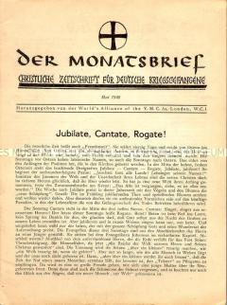 | Positive relationships with the local citizens was difficult at first. St Mary’s Church in nearby Cuckney refused to accept pows, but later sent an apology for this. There were local football matches played against the pow team. At Christmas the Duchess of Portland, (the Duke was Lord of the manor) and her daughters served the pows their Christmas dinner.  In May 1947 a Christian Conference was held at Norton camp to discuss the future of German Pows. Contributors included Pastor Werner Jentsch (Birger Forrell’s successor at the YMCA), Dr John Mott (1946 Nobel Peace Prize winner), Christian leaders, politicians and human rights activists.  A YMCA magazine was published at this camp – ‘Der Monatsbrief: Christliche Zeitung für Kriegsgefangene’ (Monthly Newsletter; Christian News for Prisoners of war). It had a circulation of 3000 and was sent to all pow camps. The articles were mainly pastoral and included bible passages, stories, and poems.  Norton camp had a well-regarded puppet theatre with Wolfgang Kaftan as the puppet-master. Shows ranged from ‘Dr Faustus’ to ‘Mr Punch Becomes a POW’, or ‘Punch Goes Fraternizing’.  Incidental information from a German theatre group journal held by the Deutsches Historisches Museum. The group toured pow camps around England during 1946. It recorded its visit to Norton Camp, 174 on 13th, 14th and 16th October 1946  Camp commandant c1945 Lieutenant Colonel W J Arnold, (I think he was from the East Lancashire Regiment).

Camp commandant 1945-1948 Major A E (Jack) Boughton. Ex-Indian army. A quote from Major Boughton - “You accuse me of being pro-German. You could not have made a bigger mistake. I am pro-humanity.” Very well respected and admired.  Closed April 1948. There was a ‘Norton Camp Closing Festival’ consisting of services of farewell meetings and concerts held between 12th April and 23rd April. Pows remained in the area until August 1948.  People associated with the camp:  Birger Forell (1893-1958); a Swedish Protestant pastor. In 1943 he was the delegate for the World Council of Churches to oversee the care of German pows in the UK. >>>  Jürgen Moltmann, theologian, was a pow at the camp. (Autobiography, including his time at Norton, see ‘A Broad Place’, SCM Press).  After the camp: Used for housing European Voluntary Workers and men from the Serbian Volunteer Corps. There have been re-unions held at the site. | 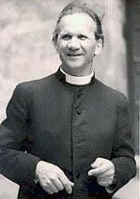

Further Information:

* ‘Warriors Through The Landscape’ by the Battle of Hatfield Investigation Society, 2019. Excellent articles about Norton and Carburton Camps – freely available online 2019 - battleofhatfieldsociety.co.uk/wp-content/uploads/2019/03/Book3-130219_compressed-1.pdf

National Archives FO 1120/230 – Re-educational survey visit reports for camps 165 to 175. Dated 1 Jan 1946 to 31 Dec 1948

Thresholds of Peace – M B Sullivan – Hamish Hamilton – 1979.

Barbed-Wire University, by Walter S Kilpatrick - published in the World Communiqué of the YMCA, Volume 1, 1949.

Klaus Loscher: Studying and everyday life behind barbed wire - Birger Forell's contribution to the theological-educational teaching in the Norton Camp / England (1945-1948). Neukirchner, 1997.

IWM have copies of the YMCA magazine published at this camp. Ref LBY E.99/1240

Second World War Experience Centre HF/LEEWW:2003.2077.2 - ‘Saunderson letters and greetings cards’, a collection of 16 letters and cards exchanged between the Saunderson family and German ex-POWs and Major Boughton.

‘Preaching Faith Before Evil’, article about Pastor Rudolf Damrath in Trinité, The Magazine of The American Cathedral in Paris, Spring 2019.

