Camp 173 (& 681) - Rockport Camp, Belfast, County Down

1947 Camp list
682(G.W.Coy) | N.I.D. | Rockport, Craigavad, Co.Down, N.Ireland | Holywood 2309 & 3090 | (Blank) | V/1270/4

Prisoner of War Camps (1939 – 1948) - Project report by Roger J.C. Thomas - English Heritage 2003
OS NGR | Sheet | No. | Name & Location | County | Cond’n | Type 1945 | Comments
 |  | 173 | Rockport, Belfast | County Down |  | Base Camp | Northern Ireland. See Camp 173 / 681
 |  | 681/682 | Rockport, Craigavon |  | 5 | German Working Company

Location:  Before the camp:  Pow Camp: Small camp – one report stated 19 Nissen type huts (not confirmed).  Various memories – “Evelyn Aickin told of an escape attempt in Rockport, when the local policeman had been out on his bicycle looking for the prisoner; Mary Strahan herself observed a policeman with his hand on the shoulder of a POW bringing him in to the former Helen’s Bay police station. Alfie Beaney and Betty Lowry remember local houses being searched, following an escape. Jim McClements remembers the high fences and barbed wire surrounding the camp. Nikko Duffin also recalls passing the camp one day, back from a swim below Craigdarragh, when he and his companions’ eyes were stung, which came from tear gas which must have been used at the camp, perhaps to restrain the prisoners. Lionel Carew, whose family was then living at Fairholme (with a flock of chickens which he recalls had a particular propensity to roam across the Craigdarragh Road), remembers parties of prisoners on their way to work on local farms singing Deutschland uber Alles. Margot McClements has evidence of the friendship between her uncle and another German prisoner – Karl Schouau, POW No. 20317. The photograph of Karl in his uniform is dated 27 April 1947, at Rockport camp though was no doubt taken a good deal earlier, as may be seen from the accompanying photograph of Karl in his POW dress with Anne McBride. It was given ‘in thankfulness for received hospitality’. It is understood that he had been allowed out to help those working with the horses at Enfield House at the top of Craigdarragh Road, and this was where he met Dickie McBride, with whom he then kept in touch for many years after his return to Germany. Their friendship is the more remarkable given that Dickie had been a staunch member of the Home Guard.“ | 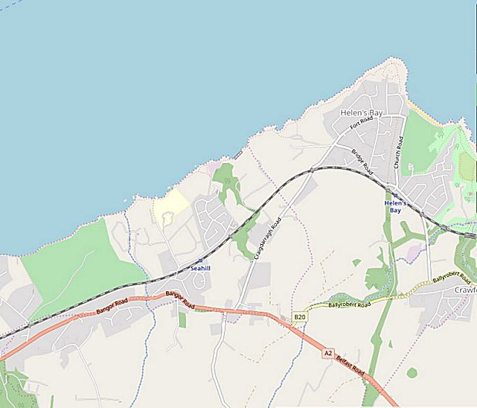
 | © OpenStreetMap contributors
(from; ‘Twixt Bay & Burn’ A History of Helen’s Bay & Crawfordsburn by the Bayburn Historical Society. Compiled and edited by Robin Masefield, 2011).

Closed 1947

After the camp:

Further Information:

National Archives FO 1120/230 – Re-educational survey visit reports for camps 165 to 175. Dated 1 Jan 1946 to 31 Dec 1948

