Camp 172 - Dog and Duck Cottage, Norton-in-Malton, Yorkshire

Prisoner of War Camps (1939 – 1948) - Project report by Roger J.C. Thomas - English Heritage 2003
OS NGR | Sheet | No. | Name & Location | County | Cond’n | Type 1945 | Comments
SE 79 71 | 100 | 172 | Dog and Duck Cottage, Norton-in-Malton | Yorkshire | 5

Location: A ‘Dog and Duck’ pub was on the Scarborough Road, Norton – NGR SE 806 723. It is labelled on the 1854 OS map. On 20thC maps the site does not show as a pub, so probably this became the ‘cottage’. Very close to Eden Camp.  Before the camp:  Pow Camp:  After the camp: A more modern, residential building is at the location of the Dog and Duck.  Further Information:  National Archives FO 1120/230 – Re-educational survey visit reports for camps 165 to 175. Dated 1 Jan 1946 to 31 Dec 1948 | 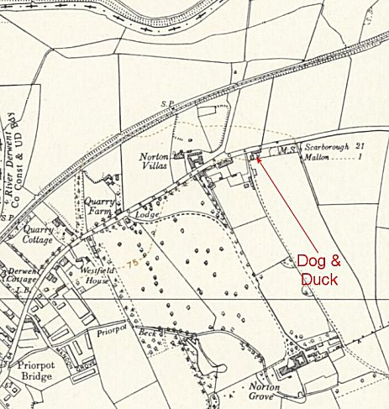
 | Ordnance Survey 1954

