Camp 171 - Isle of Man Camp, Mereside Empire Terrace, Douglas

Prisoner of War Camps (1939 – 1948) - Project report by Roger J.C. Thomas - English Heritage 2003
OS NGR | Sheet | No. | Name & Location | County | Cond’n | Type 1945 | Comments
SC 38 75 | 95 | 171 | Isle of Man Camp, Mereside Empire Terrace, Douglas | Isle of Man | 5 | Base Camp

Location: ‘Mereside’ is a hotel / guest house located at 1, Empire Terrace NGR SC 384 767 (X). Empire Terrace joins on to Palace Road. The Hutchinson Square Camp was NGR SC 381 767 (Z).  Before the camp: Mereside was used as headquarters / mail address for an internment camp.  Pow Camp: From the very limited information I have found, the camp was only operating for about 9 months. The Mereside address would appear to be the office / mail address used for several pow sites, and in particular the ex-internment site at Hutchinson Square.  Information from Wikipedia: “After Hutchinson Camp closed as an internment camp in March 1944, it was then prepared to house prisoners of war. Preparation took a long time because the original furnishings of the houses were no longer to be used, but new furniture was to be created for the purpose, with the original furniture being moved out into storage. In addition to this, the barbed wire fencing was strengthened, watch towers were erected and the guard increased.  On 22 November 1944, around 5,000 German prisoners of war arrived on the island, many of whom were allocated to Hutchinson Camp. This was the first batch of many more for the camps on the Island, now collectively known as 171 POW Camp.  The prisoners had vacated the camp again by 4 August 1945. By 24 November, the tenants and owners of the houses in Hutchinson, Onchan and Mooragh camps had received notice that their property had been de-requisitioned and they were free to move back in.” | 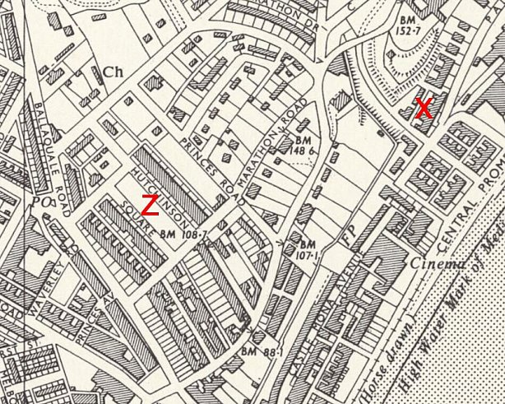
 | Ordnance Survey
After the camp: 2019 Mereside is a guest house.

Further Information:

National Archives FO 1120/230 – Re-educational survey visit reports for camps 165 to 175. Dated 1 Jan 1946 to 31 Dec 1948

