Camp 171 - Camp A, Knowsley Park, Prescott, Lancashire

Prisoner of War Camps (1939 – 1948) - Project report by Roger J.C. Thomas - English Heritage 2003
OS NGR | Sheet | No. | Name & Location | County | Cond’n | Type 1945 | Comments
SJ 465 935 | 108 | 171 | Camp A, Knowsley Park, Prescott | Lancashire (Merseyside) | 4 | Base Camp

Location:  Before the camp: Parkland  Pow Camp:  Memories of a girl living nearby – “I remember vividly the camps. [There was an internment camp and a pow camp]. The P.O.W camp was on Georgie’s field and we would go over to the camps and mock them. They used to march everywhere. We would also see the Italians and the Germans who we would see walking about and my mother used to have two of them from the Internment camp over for tea every Sunday. The Italian was called Joseph and he was very handsome and I forget the Germans name but the Italian was after my sister. The Italian, I remember, brought a huge piece of cheese for my mother which was a feast for us because of the rations. My mother used to say that if it was her son in a foreign country she would hope that some mother would do the same for her lad. Joseph and the German invited us all back to their camp where we watched them perform in a cabaret show and we loved it.” (By ‘Dot’ in Unlocking Knowsley’s Hidden Gems).  After the camp: Part works for reservoir / part Knowsley Safari Park  Further Information:  National Archives FO 1120/230 – Re-educational survey visit reports for camps 165 to 175. Dated 1 Jan 1946 to 31 Dec 1948 | 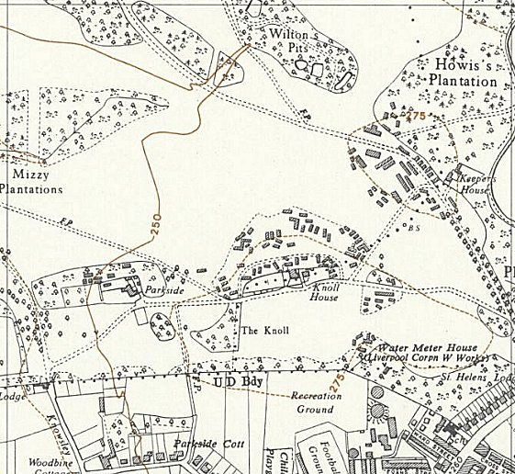
 | Ordnance Survey 1958

