Camp 171 - Bungay Base Camp, Bungay, Suffolk

1947 camp list
171 (B.C.) | P.W. Base Camp, Bungay, Suffolk | E. | Priswar, Bungay | Bungay 82 | Ditchingham | Lt.Col.H.O.Daniel T.D. | V/202/4

Prisoner of War Camps (1939 – 1948) - Project report by Roger J.C. Thomas - English Heritage 2003
OS NGR | Sheet | No. | Name & Location | County | Cond’n | Type 1945 | Comments
TM 325 866 | 156 | 171 | Bungay Base Camp, Bungay, Beccles | Suffolk | 4 |  | Former RAF airfield. Precise location not identified, NGR given for feature  centre

Location: Bungay is 9 km west of Beccles. Camp 273 very close – same camp / satellite? Neither have precise locations.  Before the camp: Airfield  Pow Camp:  Camp commandant c.1947 Lieutenant Colonel H O Daniel T.D. from the Kings (Liverpool Regiment) / Pioneer Corps.  After the camp:  Further Information:  National Archives FO 1120/230 – Re-educational survey visit reports for camps 165 to 175. Dated 1 Jan 1946 to 31 Dec 1948 | 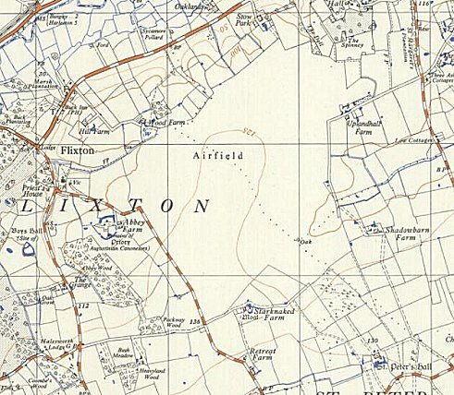
 | Ordnance Survey

