Camp 170 (& 292) - Weelsby Camp, Grimsby, Lincolnshire

Prisoner of War Camps (1939 – 1948) - Project report by Roger J.C. Thomas - English Heritage 2003
OS NGR | Sheet | No. | Name & Location | County | Cond’n | Type 1945 | Comments
TA 285 077 | 113 | 170 | Weelsby Camp, Grimsby | Lincolnshire | 4 | Base Camp | Camp occupied a circular plan within an irregular perimeter fence guarded by nine watchtowers. Site restored parkland. See Camp no.292
 |  | 292

Location: In Weelsby Woods parkland.  Before the camp: Area used during WW1 for training and transit of soldiers.  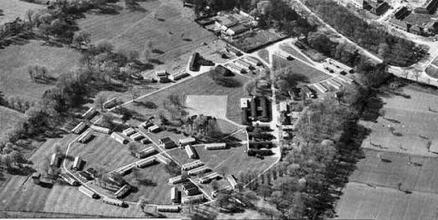 | 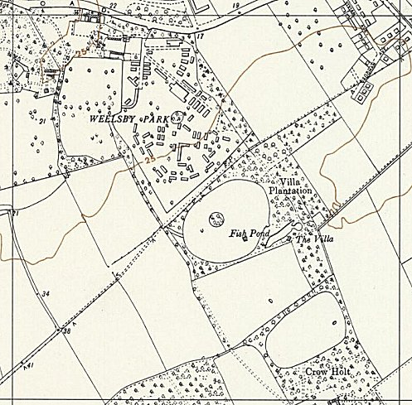
 | Ordnance Survey 1956
Pow Camp: Italian and then German pows.

Scartho Road Cemetry, Grimsby contains burials from the First and Second World Wars. Survey states – “There are also 17 war burials of other nationalities many of them German prisoners of war from the camp at nearby Weelsby.” Many?

After the camp: Used as displacement camp for 900 Polish troops. From 1951 reverted to parkland.

Further Information:

National Archives FO 1120/230 – Re-educational survey visit reports for camps 165 to 175. Dated 1 Jan 1946 to 31 Dec 1948

National Archives DEFE 51/65 – Grimsby: Weelsby Park former PoW camp; disputed compensation claims, and settlement thereof. Dated 1953-1956

