Camp 169 (& 613 / 698) - Tollerton Hall Camp, Tollerton, Nottinghamshire

Prisoner of War Camps (1939 – 1948) - Project report by Roger J.C. Thomas - English Heritage 2003
OS NGR | Sheet | No. | Name & Location | County | Cond’n | Type 1945 | Comments
SK 6153 3349 | 129 | 169 | Tollerton Hall Camp, Tollerton | Nottinghamshire | 5 |  | Restored parkland. Evidence of hut  footings also visible at SK 6136 3457. See Camp no.613
 |  | 613

Location: About 8 km SE of central Nottingham.  Before the camp: Country estate. After 1929, it ceased to be a private house and the owners turned it into a residential sports club and hotel. At the start of WW2 it was requisitioned and used by the Army, RAF, and the US 507th Parachute Infantry Regiment up until May 1944. The 507th arrived in March 1944 and the camp was then described as a tent city – with officers using the Hall.  Pow Camp: Reports state that Italian and then German pows were held here and guarded by Polish soldiers.  Incidental information from a German theatre group journal held by the Deutsches Historisches Museum. The group toured pow camps around England during 1946. It recorded its visit to Tollerton Hall Camp, 698 on 30th October 1946. (Note use of 698 at this time).  After the camp: The Hall was converted to a junior seminary for the Roman catholic Church. 1987 the Hall was converted to offices.  Further Information:  National Archives FO 1120/230 – Re-educational survey visit reports for camps 165 to 175. Dated 1 Jan 1946 to 31 Dec 1948 | 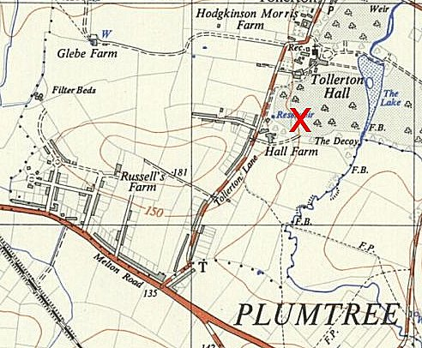
 | Ordnance Survey 1952

