Camp 167 - Shady Lane Camp, Stoughton, Leicestershire (aka Evington)

1947 Camp list
167(G.W.C.) | Shady Lane Camp, Stoughton, Leicester | N. | Priswar, Oadby | Oadby 584 | Thurnby | Lt.Col.E.L.Farnell | v/1453/2

Prisoner of War Camps (1939 – 1948) - Project report by Roger J.C. Thomas - English Heritage 2003
OS NGR | Sheet | No. | Name & Location | County | Cond’n | Type 1945 | Comments
SK 627 024 | 140 | 167 | Shady Lane, Stoughton, Leicester | Leicestershire | 5 | Base Camp

Location: On the SE edge of Leicester.  Before the camp: From 1942 the site was in military use. For a short time used by the US 504th Parachute Infantry Regiment before D-day.  Pow Camp: opened in 1945. Italian and then German pows.  The camp had a weekly newspaper; Der Neue Weg (The New Way).  Memories – “Karl Hohn, who was sent to Evington as an eighteen-year-old prisoner, having been wounded and captured in the Ardennes region of France during the Allies’ advance towards Germany. He confirmed that relations between the local population were friendly; indeed, he said, compared to conditions in Germany at the time, Evington seemed like paradise, what with biscuits and invitations to Sunday and Christmas dinners with local families. He even married a local girl while still a prisoner – although he had to return to the camp each evening!” (www.evingtonecho.co.uk/shady-lane-pow-camp/ )  Camp commandant c.1947 Lieutenant Colonel E L Farnell (Possibly from the Royal Corps of Signals).  The camp closed in 1948.  After the camp: Occupied by squatters when the camp closed. Part used by a riding school. Arboretum from 1970. | 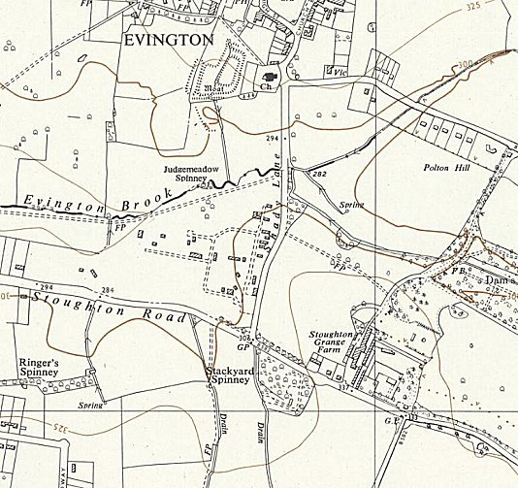
 | Ordnance Survey 1956
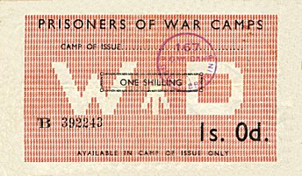
Further Information:

National Archives FO 1120/230 – Re-educational survey visit reports for camps 165 to 175. Dated 1 Jan 1946 to 31 Dec 1948

Leicester and Rutland Record Office – Papers including letters from German prisoners of war based at Stoughton and Scraptoft Camps. Dated 1946-1960. Ref DE6888

IWM has copies of the camp newspaper from 1947 to 1948

< Camp 167 token money. Could only be used in the camp as stamped. The back was stamped after each use.

