Camp 166 - Wollaton Park Camp, Nottingham, Nottinghamshire

1947 Camp List
166(G.W.C.) | Wollaton Park Camp, Nottingham | N. | Priswar, Nottingham | Nottingham 73025 | Nottingham | Lt.Col.H.S.Hobby | v/1453/2

Prisoner of War Camps (1939 – 1948) - Project report by Roger J.C. Thomas - English Heritage 2003
OS NGR | Sheet | No. | Name & Location | County | Cond’n | Type 1945 | Comments
SK 529 393 | 129 | 166 | Wollaton Park Camp, Wollaton Hall, Nottingham | Nottinghamshire | 4 | Base Camp | Parkland

Location: Just to the W of Nottingham.  Before the camp: Large estate. American troops of the 508th Parachute Infantry regiment based here.  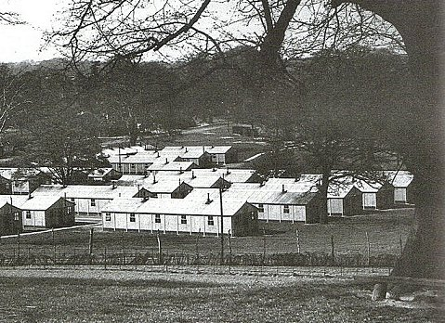  Pow Camp: Italian and then German pows. Believed that the first batch of Italians converted the troop camp for pow use.  Pow camp opened in 1945, announced in local press.  An escape attempt was made in April 1947 – “After bloodhounds had been used by Nottingham police, three German prisoners of war who escaped from Wollaton Park camp on Tuesday were found yesterday in a disused farm shed at Heanor, 18 miles away.” (Gloucester Citizen).  < Huts in the camp. 1 has been converted for use as a café. (www.flickr.com/photos/45904802@N08/5442836277 ) | 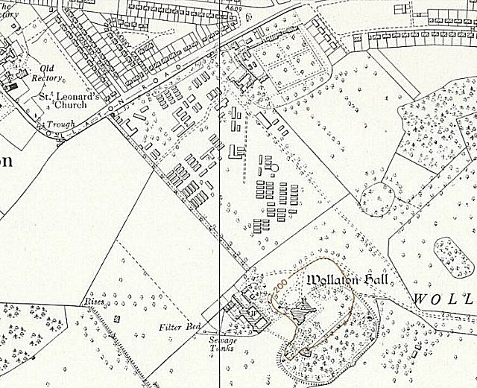
 | Ordnance Survey 1958

During 1946 German pows were shipped back from America, they expected to be returned to Germany. One pow, Paul Seufert, recalled; “We could hardly sleep for thinking what home would be like…” but after they docked at Liverpool the message was soon spread that they; “had been handed over to the Tommies. Suddenly only British officers and soldiers with fixed bayonets were to be seen; the Americans had disappeared. Next day at Woolaton Park we were put into fresh units, filed in the usual way, medically inspected and interrogated. Each of us got a new number. It was like being made prisoner a second time.” (Thresholds of Peace, p170, M B Sullivan, 1979, Hamish Hamilton). No record of disturbances arising from this situation in this camp, but morale was low.

In 1946 families from across the Nottingham district sent invitations to the military authorities at Wollaton Park following an article in a newspaper. A map was included in the article illustrating a five-mile radius around the camp.

The camp participated in activities related to re-education. There was a camp newspaper – ‘Neues Leben’ (New Life).

The camp seems to have had good relations with the neighbourhood - “German POWS Thanks - Nottm. People ‘Gave us Hope’. Tribute to the tolerance, generosity and hospitality of Nottingham citizens was paid by Lagersprecher (camp spokesman) Feldw. Hans Rogge of the Wollaton Park German POW Camp at a farewell concert held in the Salvation Army Hall, Nottingham, last night….’Thank you for giving us hope for the future.’… Appreciation of the understanding shown by Col. H.S. Hobby, Commandant of the camp, was also expressed.” (Extracts from article sent to me – from 1947, but without the name of the newspaper).

Camp commandant c.1947 Lieutenant Colonel H S Hobby (I think he was from the East Yorkshire Regiment and had previously been awarded a MC).

The camp closed in 1947.

Postal items: POW letter-sheet, 11 March 1945 in German to Germany

After the camp: Reverted to parkland

Further Information:

National Archives FO 1120/230 – Re-educational survey visit reports for camps 165 to 175. Dated 1 Jan 1946 to 31 Dec 1948

IWM have a copy of the camp newspaper dated 1 Mai. Ref LBY E.J. 402

