Camp 165 - Watten Camp, Wick, Caithness

1947 Camp list
165(B.C.) | Watten Camp, Watten, Wick, Caithness | Sc. | Priswar, Watten | Watten 219 | Watten | Lt.Col.R.L.T. Murray | V/202/4

Prisoner of War Camps (1939 – 1948) - Project report by Roger J.C. Thomas - English Heritage 2003
OS NGR | Sheet | No. | Name & Location | County | Cond’n | Type 1945 | Comments
 |  | 165 | Watten Camp, Watten, Wick | Caithness |  | Base Camp | Scotland

Extensive details of this camp and some of those held there are in the book: ‘Camp 165 Watten’ by Valerie Campbell – 2010 – Whittles Publishing. I therefore give a summary and some further details here.

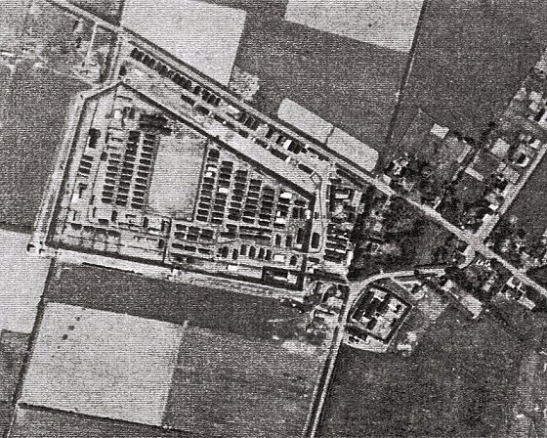 |  | 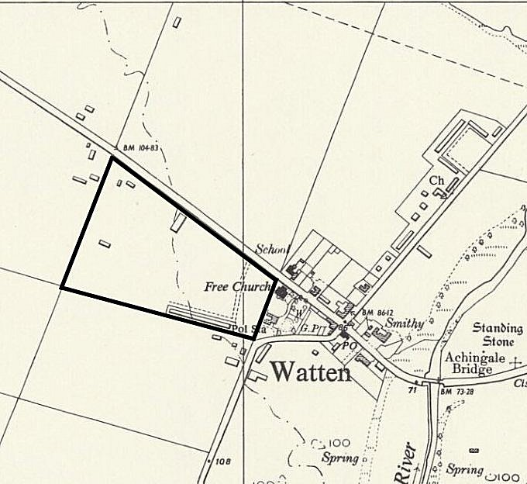
 |  | Ordnance Survey 1959 with general camp area marked

Location: NGR ND 238 545. Camp 165 was on the north-west edge of the small village of Watten in Caithness. The main road through the village and alongside the camp is the A882, the smaller road running SW to NE is the B870. About 0.75km to the north is Loch Watten.

Before the camp: Fields. The wide area around Watten was in use for military training for many years prior to WW2. A flagstaff, targets and rifle range were mapped on the edge of Loch Watten close to the village in 1905. Agricultural land at the side of the village was purchased and became a military camp in 1943 and was used for a short time by Polish troops. Ex-military camps all around the UK were acquired as pow camps after D-Day, especially those with readily available hutted accommodation. Watten was ideal.

Pow Camp: The camp number – ‘165’ – was originally allocated to Kirkwall Camp, Orkney. After the pows there were dispersed in late-1944 / early–1945, the number was re-allocated to the newly opening camp at Watten.

The camp has the pattern of a standard camp with a pow compound within barbed wire fencing and guards’ huts at the front alongside the road.  The first prisoners arrived in May 1945, most by rail, some by lorry. Some came from Normandy via transit/interrogation camps (‘Command Cages’), others were transferred here from other camps. The camp was originally for ‘other ranks’ – the ICRC Report for June 1945 recorded 1 officer, 71 non-commissioned officers, 429 men.  The pows were mainly German, with some Austrian, Belgian and Polish prisoners – some Dutch pows were included for a short while. Camps for single nationalities were preferred and by the end of 1946 nearly all were German.  The camp had a changeable population with prisoners being transferred to and from other camps. The peak number of pows reached 2800 in December 1946, though the camp had an official capacity of 2000. At times there were some protected personnel at the camp. |  | 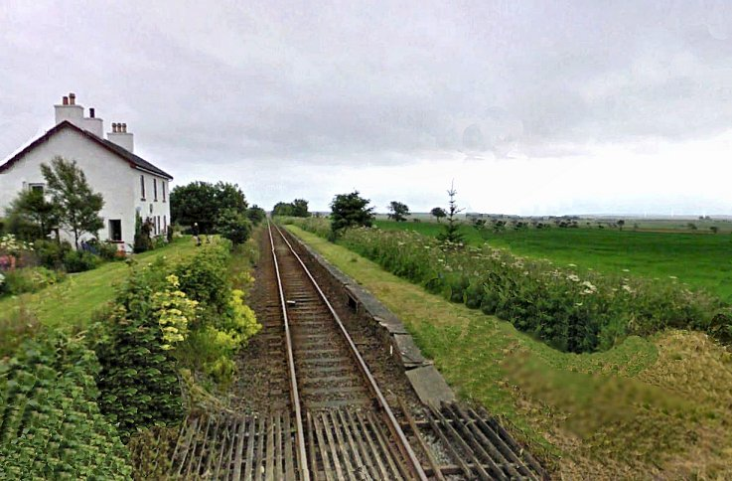
 |  | Watten station was 2km north of the village. (‘Photo-shopped’ picture to remove various modern features).
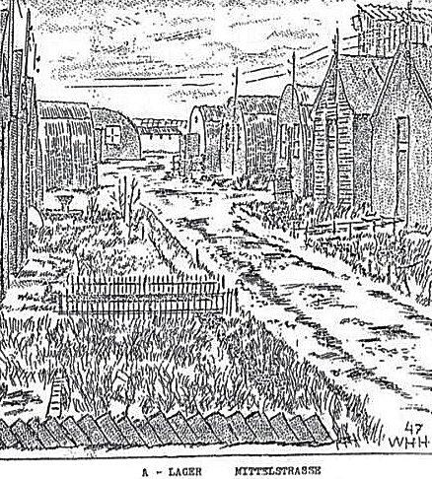 | The camp was surrounded by a double barbed-wire fence with watchtowers. Inside were rows of huts for the pows, an infirmary, cookhouse, bakery, two chapels, barbers, classrooms, workshops, a library/reading room, a detention hut and a theatre. Most huts were Nissen type, some were joined together. Additional huts were built at various times for additional accommodation and facilities. Buildings needing stronger structures, (e.g. latrines and showers) were made from concrete blocks.  The infirmary was larger than at many pow camps. It also housed some pows who were suffering from mental illnesses.  There was a band/orchestra, theatre group, choir, piano and assorted musical instruments Films and newsreels were shown weekly and the camp had access to a radio. When pow regulations were eased, dances and music concerts were held at the camp. Access to these facilities depended on the category of prisoner.  Nissen huts were provided for staff and guards just outside the perimeter fence.  The status of the camp changed in November 1945. There were calls to segregate hard-line Category C (‘black’) Nazis in separate camps where they could not influence others, but this was considered to be impractical. However, within certain camps, separation of different categories of pows was put into place. Camp 165 was identified as a suitably large site for this to happen. The camp was divided into different compounds for this purpose;  Compound A was used to accommodate low risk pows – Category A, ‘white’. These prisoners were allowed to work on nearby farms. As security restrictions were gradually decreased, some lived in an area of the camp without barbed-wire fencing, others were billeted at local farms.
Title: A LAGER MITTELSTRASSE - Compound A Middle Street.

Compound B with additional security, held Category B, ‘grey’ and Category C ‘black’, hard-line Nazis. Re-education programmes were in place for many of these prisoners. This compound was sub-divided further:
- Category B, especially younger pows thought likely to respond to re-education. A large group of these were later sent to Camp 180, (Radwinter), a re-education ‘Youth Camp’ for pows aged 18 to 26 to spend 3 months there.
- Category C / C+, included some hard-line Nazi SS civilians. A limited number of these were allowed to work at local farms.
- Officers
There was a high security area for pows requiring further investigation, or who were awaiting war crime procedures.

Many of the pows held in Compound B were horrified to find themselves grouped in with extreme hard-line Nazis. Some protested and appealed to be regraded. Others, however, were most definitely dangerous, Nazi thugs. Colonel Faulk, a senior officer of the POW Department, described what he found on a visit to the compound in May 1947:

“One expected depression, animosity, defiance. But what one found was, first, a deep hatred against everything British, which exceed their passionate contempt for Bolshevism. ’We’ll go to the Russians,’ they say. ‘They’ll give us arms and we’ll put paid to these English dogs. Then it will be their turn.’ Secondly, the old arrogance hits you, particularly with the officers who talk less than the ORs but behave ‘correctly’. At interrogations they are superior and contemptuous. Their answers are civil but the tone is barbed. The ORs seem to be drilled in the answers they give.” (Thresholds of Peace, p303).

Some months after this report SS-Obergruppenführer d’Alquen (see below) became the new officer leader. It was noted by visitors to the compound that morale and discipline considerably improved with his arrival.

Compound B naturally attracts more attention, but also more wild comments such as a headline in ‘The Scotsman’, 2 December 2007: “How top Nazis were brought to a secret Scottish prison camp for brainwashing”. I cannot find any details as to how this camp was any more secret than any of the other camps that held ‘black’ Nazis. There were restrictions on information allowed to be given regarding the names and locations of individual pows which applied to all camps. As censorship restrictions were eased, many pows included the camp address on the back flap of the standard letter forms - incoming mail was directly addressed to the camp. News articles were published about Watten Camp, some written by the camp commandants. The ICRC inspected this camp under the same rules as any other….

After the camp closed, many pows were free with their praise of the camp. However, some stated clearly that they did not wish to talk about being held in the ‘black’ compound – it was a dark time for them – and more to the point, they were wary of de-Nazification trials and employment restrictions back in Germany. I can find no record of prisoners complaining of ‘brainwashing’ or mistreatment at the camp. Pows across the country were shown films of war crimes – many were appalled, others dismissed the films as propaganda. Considering the high-praise the Camp Commandant received, it seems a pity to slur his, and the other guards’ names, by making them complicit with ‘brainwashing’ with no apparent evidence. Standard re-education activities occurred at this camp as elsewhere.

There was a camp newspaper / magazine – ‘Nordlicht’ (Northern Lights). Articles concerned world events and entertainment, but also items of interest to the pows themselves, such as one entitled; ‘Health problems in captivity’. An article written by Dr H W Thost, (a Nazi journalist expelled from London in 1935 and held at Watten), described the ‘highlights’ of working in all weathers on gathering the peat crop. “He records [Nordlicht October 1947] how for the 100 men who boarded the five Bedford trucks every morning at 7 a.m. for a seventeen-mile drive to work, the red-haired girl who always stood at Halkirk stop waiting for the 8 o’ clock bus was the most welcome sight of the day. Neither side ever spoke or waved a hand, but for the POW’s it was visual proof of a world closed to them. How much greater was the joy and gratitude of these men at Watten when they were asked by local people to join in with their Highland Games, and thanks to support from their commandant, competed in some events. After admiring Highland dress, bag-pipes, and dancing, they took second place in the tug-of-war. The applause from the former enemy was heart-warming to them.” (Details from an article ‘The Boys Own Papers’, by Ingeborg F. Hellen, in the German Historical Institute London Bulletin, No 2, 2008). | 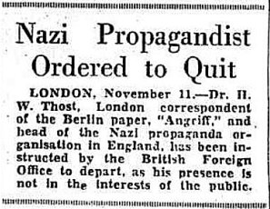

I have seen one report that there was a Camp 165 newspaper called “Unser Lager” (Our Camp) – this could have been at a different time to Nordlicht, or may have been the title of an article (?).

Gunter d’Alquen (see below) the camp leader was allowed to publish ‘Der Wattener’ a monthly magazine for the pows.

Prisoners from ‘Compound A’ held Presseschau (Press Reviews) where news articles were translated and read to them, followed by discussions. (Reported in Nordlicht, 1 September 1947).

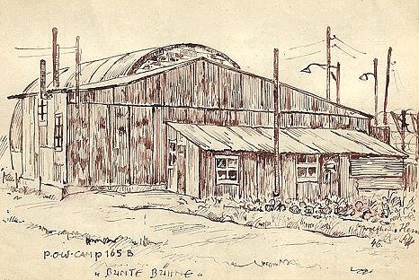 | < Illustration from a booklet produced by a pow at Watten and dedicated to ‘our comrade Daniel Sartor on his birthday’. Dated 1 January 1947. This picture entitled ‘Bunte Bühne’ (Colourful stage) is probably of the theatre or stage hut.  The theatre was an important part of the camp for the pows. Building the theatre within one of the Nissen huts began in March 1946. It held plays, concerts and dances – 150 performances by September 1947 - programmes for some of these events were printed.  - - - - - - - -  There were some disputes at the camp, mainly regarding work, but other than insubordination from some, no serious incidents are recorded.  There were some escape attempts. The seriousness of some of these has to be questioned; “”…Lt-Col Murray not only instructed his men to find the prisoners, but also took part in looking for them himself, driving around in his own private car. Indeed, he recaptured some, throwing them into the car and returning to the camp.” (Camp 165 Watten – p51). On other more determined attempts, prisoners evaded capture for several days, and one managed to stow away on a ship at Leith before he was re-captured.

One escape attempt border’s on being ludicrous. Two Germans in their late twenties left the camp making their way to Thurso by the evening. They went with two girls to the local cinema where they were recaptured. They were escorted back to the camp, but escaped again just two hours later. The following day they were spotted with the two girls again in Thurso. The two pows evaded capture despite shots being fired at them. They managed to catch a train and made it to Perth where they were recaptured. Now I’m guessing, but it seems the two insubordinate, young men must have known the girls, (perhaps from the dances held at the camp?) – and went to meet them. Going to the cinema is hardly an ‘escape attempt’. After capture, and barely any consequences for the two ‘escapees’, in a further act of defiance, they went off to meet the girls again. This time things got serious with shots fired, and rather than face the music, they did a runner…. ?

Punishments for escape attempts were usually a period of time, up to 30 days, in the detention hut.

In early 1947, when pows were being transferred from Canada, members of the Waffen-SS, Luftwaffe officers and forty U-boat commanders were sent to Watten. They were classed as “unrelenting militarists”, however after further questioning, many were reclassified and approved for release.

The camp was re-inspected by the ICRC in August 1947. The lead delegate, Frédérick Bieri, reported that morale at the camp was as, “good as it can be in the circumstances”. Anxiety was expressed about when they would be repatriated, and some pows complained about the category they had been placed in (Category C had greater restrictions).

By January 1948 the numbers had decreased to nearly 700 pows, including 104 officers. 689 were Germans, 2 Austrian, 1 Argentinian and 1 Yugoslavian. The security rating of the camp was downgraded.

There were six deaths in the camp, five from medical causes and one suicide. I have only found details for three of the deaths -

Feldwebel Karl Balzer, Pow.No.310095. Watten-Wick Kgf.Lg.165. Died 16.09.1947. Now buried at Cannock Chase.

Maat Erich Kollek, Watten Caithness 165.Kgf.LG. Died 15.01.1947. Now buried at Cannock Chase.

The suicide was subject to a fatal accident inquiry held at Wick Sheriff Court in 1948. “Fritz Teitgen, German prisoner of war, No.B 1000 Army, No. 165 prisoner of war camp, Watten, Caithness, died 17 Dec 1947” - National Records of Scotland reference SC14/15/1948/4. [It was noted by d’Alquen, the German camp leader, that the British guards on duty paraded at attention as the coffin of the suicide victim was carried through the gates and that this gesture was much appreciated].

The camp was closed in Spring 1948 with the last 200 pows transferred to other camps prior to repatriation.

Camp commandants:

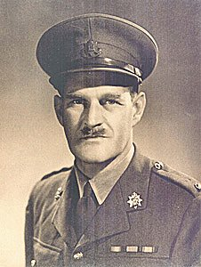 | < Lieutenant-Colonel Paris Hilary Drake-Brockman (not Brockham listed elsewhere).  During his service in WW1 he was wounded three times. He later became Commanding Officer with The East Surrey Regiment. Brief details of his career and obituary are available from:  http://www.queensroyalsurreys.org.uk/index.shtml  Commandant of Camp 165 from early 1945 to November.  Lieutenant-Colonel Rupert Luxmoore Tanner Murray >  Served with the Black Watch including time in Ireland, Palestine and Crete. He was captured in Crete 1941, and was a pow until the end of the war.  On return to the UK he was made commandant of a camp near Edinburgh and then of camp 165 from November 1945 to 1948. A pow described Murray; “with bare knees and seven feet tall”. He was able to speak simple German and was referred to by some pows as ‘Irene’ because he wore a kilt. (Thresholds of Peace, p301) | 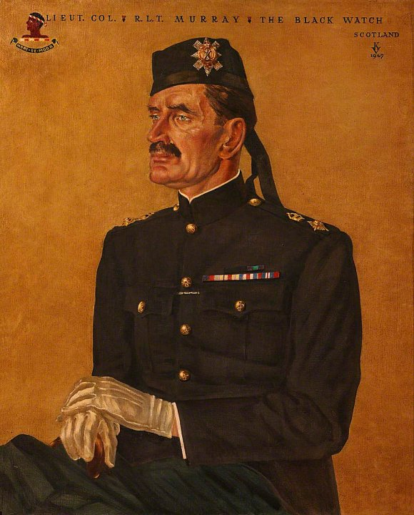

He retired in 1949. His command was praised in ICRC reports and he was well respected by guards and pows.

After the camp: The camp was removed and replaced by housing and a playing field in the late 1960’s. 2019 residential area and football pitch. There are information signs for the camp.

Further Information:

National Archives FO 939/199 – Political gradings of Camp 165, Watten Camp, Wick, Caithness. Dated 1947-1948.

National Archives FO 1120/230 – Re-educational survey visit reports for camps 165 to 175. Dated 1 Jan 1946 to 31 Dec 1948

Vertical aerial photograph RAF 106G/Scot/UK 70, 4050-1, flown 9 May 1946.

IWM have a copies of the camp newspaper Nordlicht – Ref. LBY E.J. 404

IWM – Private papers of R Weitzel – Ref. Documents.8055. A memoir of a German called up in 1942, detailing experiences on the Eastern front; capture in France, September 1944; reception and interrogation at Kempton park; time at various camps; the screening process which resulted in his transfer to Watten classified as a Nazi. Particular reference to the re-education process.

http://canmore.org.uk/site/202517

People Associated with Camp 165

One guard, an Austrian born sergeant, nicknamed ‘Hermann’ was noted by several pows – in a negative way. Regarded as being viscous, it was apparently him who gave the camp the unpleasant nickname of ‘Little Belson’.

Camp Leaders:

At the start - Camp leader Oberführer Wilhelm Macht / Assistant Wilhelm Brinkenmeyer

Later, when the camp was split into compounds, there were different compound leaders:

Compound A:
Leader; Oberstabsfeldwebel Walter Lindner. Bailed out from a JU 88A-4 on its return from a bombing raid on Bristol, March 1944, previously held at Camp 21 Comrie.
Assistant; Stabsfeldwebel Bruno Rokall. Also transferred from Camp 21.

Compound B:
Leader; Hauptfeldwebel Hugo Fischer von Weikersthal.

Officers:
- Leader; SS-Oberführer Harro Witt.
- Oberstleutnant Ehrhardt Unger. Unger had previously been at Camp 191, Crewe Hall, also as a camp leader until dismissed from that post after a German pow had been beaten up as a ‘traitor’.
- SS-Obergruppenführer Gunter d’Alquen, see below.

POWs were often transferred from camp to camp. For this camp brief details follow of some notorious and senior prisoners that were held along with the extremely unpleasant hard-core Nazi thugs.
SS-Obergruppenführer Gunter d’Alquen.  A member of the SS from 1931. As a journalist he gained the attention of Heinrich Himmler who appointed him in 1935 as the chief editor of ‘Das Schwarze Korps’ (The Black Corps), the weekly newspaper for the SS.  He held various other editorships and became head of the propaganda department in 1943. d’Alquen’s publications helped popularise the idea of Jews as “vermin” – it sold up to 750,000 copies per week.  d’Alquen was held at a pow camp in Italy. Transferred to the UK, he was interrogated at London District Cage before being sent to Camp 18 (Featherstone Park) in July 1947. A few months later he was sent on to Watten. He became a camp leader and was allowed to publish ‘Der Wattener’ a monthly magazine for the pows. He was amongst the last batch of pows to be repatriated from the camp.  In his trial, like so many Nazis, he denied any knowledge of the concentration camps – and yet his publications mentioned them several times. He was sentenced to 10 years imprisonment, but instead he was transferred to the U.S. where he worked for a few years with the CIA. When he returned to Germany a de-Nazification court found him guilty of ‘incitement to murder by means of publication’ and fined him 60,000 DM in 1955, and then a further 28,000 DM in 1958.  SS Sturmbannführer Paul-Werner Hoppe.  SS member from 1933 and member of the Concentration Camp Inspectorate. He was based at Dachau and Auschwitz and served for a short time on the Eastern Front where he was wounded. He became the commandant of Stutthoff concentration camp, Poland between 1942 and 1945. A gas chamber and crematorium were added to the camp in 1943 – mobile gas wagons were also used. It was reported that an experimental factory for making soap from human corpses was built here, (see Russia At War 1941 to 1945, by Alexander Werth). It is estimated that between 63,000 and 65,000 prisoners of | 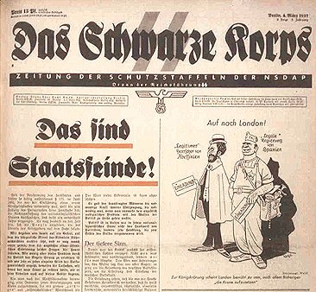
Stutthof concentration camp and its subcamps died as a result of murder, epidemics, extreme labour conditions, evacuations, and lack of medical help.

Hoppe was fortunate to have been captured by the British as many of the camp guards were executed in Poland. He was held at Watten between August 1947 and January 1948 with a short time spent at the interrogation centre in London.

From Watten he was returned to Germany for trial. However, he managed to escape and lived in Switzerland for a number of years. He was re-captured in 1953 and sentenced to just nine years imprisonment.

Werner Hans Kolln – listed as a U-boat commander, but I have been unable to trace him in commander lists. Killed in a train accident 17 April 1948 on his way home to Hamburg.

Captain Otto Kretschmer. Brief details given under Camp 1.

Dr. Paul Schröder. Rocket scientist who helped to develop the V2 rocket. Held at Camp 184 Llanmartin, before being transferred to 165. Various accounts indicate that he was a most unpleasant, vindictive man – and a definite Nazi. He moved to the US in 1952 where he worked with the US Air Force until 1958, then returned to Germany.  SS-Sturmbannführer Max Wünsche. Member of the SS from 1933, joining the SS bodyguard unit providing security for Hitler in 1938. Saw service in The Netherlands, France, the Balkans and on the Eastern Front for which he was awarded the German Cross in Gold and the Knight’s Cross. He was transferred back to France in 1943 commanding the 12th SS Panzer regiment. He saw action against the allies during June. He was captured by the British in August and sent to camp 165 as a high-ranking officer from 1945 to 1948.  After his release, Wünsche returned to Germany and became manager of an industrial plant in Wuppertal.  SS-Sturmbannführer Max Wünsche in Normandy 1944 > | 