Camp 165 - Kirkwall Camp, Orkney

Location:  Before the camp:  Pow Camp: The camp is listed in a Pioneer Corps list of camps. There is also a mention of pows in Kirkwall in the book, ‘Churchill’s Prisoners’ (p42) - “By 1944, the shortage of workmen in and around Kirkwall was acute….. Cargoes were arriving now without interference by the enemy, and parties of Italians were brought into Kirkwall to assist with the unloading.”  I have found no evidence of what could be called a camp with barbed wire fences. There may have been a main office / hostel / site in or near Kirkwall and the use of billets and that this was allocated the number Camp 165. This was separate from the main camps of Italian pows utilised for building the Churchill Barriers..  When this camp closed at the end of the war – Camp number 165 was allocated to Watten  After the camp:  Further Information: | 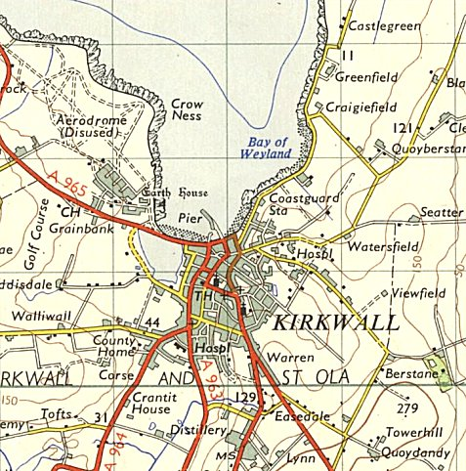
 | Ordnance Survey 1959

