Camp 164 (& 245) - Weston Lane Camp, Otley, Yorkshire

Prisoner of War Camps (1939 – 1948) - Project report by Roger J.C. Thomas - English Heritage 2003
OS NGR | Sheet | No. | Name & Location | County | Cond’n | Type 1945 | Comments
SE 192 465 | 104 | 164 | Weston Lane Camp, Otley | Yorkshire | 4 | Base Camp | Site occupied by housing. See Camp no.164 /245
 |  | 245 |  |  |  | German Working Camp

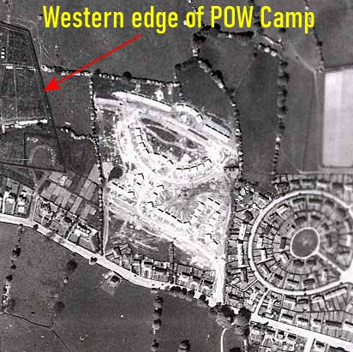  Location: The NGR above is not quite correct. The main camp was at NGR SE 190 465 (X), and the annexe at SE 184 467 (Y). I have marked the corners of the perimeter of the main camp - which can still be seen on the 1956 OS map - with red spots.  Before the camp: Main camp – fields. Annexe part army camp within Weston Park Estate.  Pow Camp: The camp was used from 1944 to 1948. There were two sites – the main camp (numbered 164 and 245) and an annexe.  “The site has been identified from air photographs as a series of structures, earthworks and cropmarks. | 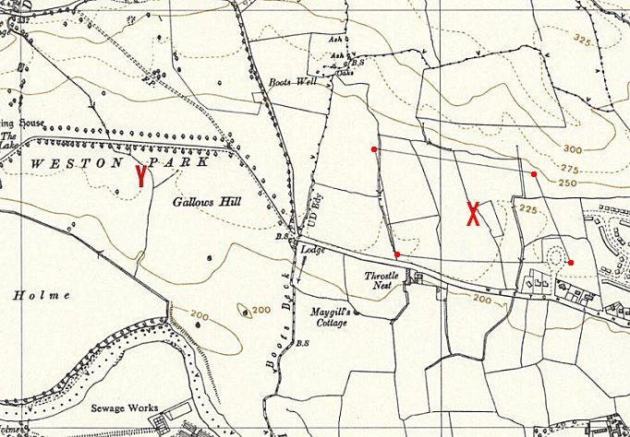
 | Ordnance Survey 1956
Some of the cropmarks may be associated with the movement of personnel along regular routes between buildings. Various internal compounds, permanent buildings including huts and a guard block and the perimeter fence have been identified. Further information from ex German POWs indicates that there were a number of watch towers spaced at regular intervals along this perimeter fence. They also suggest that much of the accommodation was in tents.” ( www.pastscape.org.uk/hob.aspx?hob_id=1369126 )

An interesting set of facts was produced by Abbey Grange C of E Academy, Leeds –
1) Situated on Weston Lane. The land was owned by Weston Hall. A camp for British Soldiers was close by at Farnley Hall.
2) Seven POWs were buried in Otley Cemetery. Their bodies were later moved to Cannock Chase German Cemetery. [Brief note below].
3) People living in Otley today remember POWs marching through the town from the railway station to the camp.
4) At first the POWs lived in tents. Nissan huts were built at a later date.
5) Some POWs worked in Otley hospital as gardeners and porters. At the end of the war two POWs worked there for the rest of their lives.
6) During the heavy snow in the 1947 winter some POWs from Otley were sent to help clear the Settle to Carlisle railway line.
7) Many POW made friends with local families. Sunday afternoons were a popular time for local people to walk up to see the camp. It was not unusual for cigarettes to be pushed through the fence wires as a gift to the POWs.
8) The camp was closed in 1948.
9) The Second World War Experience in Horsforth, Leeds has a painting of the camp in it’s collection. It was painted by a POW.
10) St Joseph’s Primary School have a wooden carving by a POW on display in their reception. [It shows St Joseph and baby Jesus].

Regarding the heavy snow in the1947 winter – a report states that many of the pows were not happy at doing this work. They were handed shovels before they boarded the train taking them to the track section closed by snow. On the first day, over half the pows threw the shovels out of the train window – after that the shovels were carried in the guards’ wagon. (Detail from ‘Children in the Second World War’ by Amanda Herbert-Davies, 2017, Grub Street Publishers).

Memories - “Mr Lutz remembers that as an officer he was allowed to travel outside the camp, but on one occasion missed his train and was left stranded in an unfamiliar town, where the police arranged for him to be put up for the night. He has described how the other guests at the hotel were astonished to see a German officer in full uniform at the breakfast table.

Another internee Fritz Weiss remembers leaving the camp each day by lorry to go to railways stations such as Bingley and Keighley to help unload trains. He then went to live and work at Otley Hospital for three years. His time as a PoW came to an end in December 1948, after which he spent another three years working with the British Army bomb disposal unit. Mr Weiss was one of a number who stayed on in England. He married a local girl, and spent the last 36 years up to retirement selling ice cream in the Aireborough district.

Gunter Reichel, was taken to the Otley camp in May 1945 and stayed there for 12 months. He married an English girl in 1948 and was officially released as a prisoner of war less than a month later. He remembers that from Christmas 1946, by which time he was at the Horsforth camp, PoWs were allowed out on their own for the evening as long as they were signed out by British people. He had his first pint of English beer at The Old Ball in Horsforth in 1947, but had to stand outside as PoWs were not allowed in. Later he used to visit the British Legion in Manningham with his brother-in-law, and after several weeks was asked if he would like to join.” (Extracted from an article in the Wharfedale & Airedale Observer).

Two pows were shot and killed when they crossed the perimeter fence. Date?  Five other pows died while pows at Otley.  After the camp: All physical evidence of the camp has been destroyed by the construction of the Weston Estate housing development which began in the late 1940’s.  Further Information:  Research was carried out on Weston Park POW camp including interviews with ex German POWs - a full archive of the information recorded, and paintings by a pow Heinz Lutz, is held by The Second World War Experience Centre in the Wetherby and Otley Museum  Picture by Heinz Lutz; with the kind permission of the War Experience Centre war-experience.org/  Vertical aerial photographs - CPE/UK/2557 4108 28-Mar-1948 and RAF 541/32 4088 18-May-1948 | 