Camp 162 - Naburn Military Hospital, Naburn, Yorkshire

1947 Camp list
162(P.W.Hosp) | Military Hospital, Naburn, York | N. | Priswar, York | York 77271 | York | Major J.T.Corrie | V/1395/2

Prisoner of War Camps (1939 – 1948) - Project report by Roger J.C. Thomas - English Heritage 2003
OS NGR | Sheet | No. | Name & Location | County | Cond’n | Type 1945 | Comments
SE 607 480 | 105 | 162 | Military Hospital, Naburn, York | Yorkshire | 4 |  | Site occupied by a retail outlet

Location: Just S of York  Before the camp: York City Asylum, 1906 to 1927. York City Mental Hospital 1927 to 1948. During the war one ward on each side of the hospital was used by the military as Naburn Emergency Hospital Scheme until 1942, and a hutted military hospital was built in the grounds.  Pow Camp: The pow hospital was in the hutted area to the east of the main drive.  The pow hospital received many hundreds of severely under-nourished German soldiers after the end of the occupation of the Channel Islands in May 1945. “A German staff of 90 doctors, orderlies and nurses, under the excellent Colonel Wild, RAMC, nursed them back to strength; but some three hundred and sixty could not be made fit for work and were repatriated.” (Thresholds of Peace, M B Sullivan, Hamish Hamilton, 1979).  Camp commandant c.1947 Major J T Corrie (Possibly from the Manchester Regiment)  An entry from Hansard indicates that Ukrainian pow patients were also held here:  “Mr. Cooper asked the Secretary of State for the Home Department how many Ukrainians, who came to this country through Italy, have now been ​ transferred as civilians to the European voluntary workers' organisation; and how many of these are at present incapacitated from illness and recently moved from Naburn, Yorkshire, to Diss, Norfolk; what is being done with these sick cases; and if it is intended to deport them to Germany.  Mr. Ede - None of these persons have yet been given civilian status as European voluntary workers, but it is hoped that selection teams will shortly be visiting the camps. I am informed that on 9th July there were 158 | 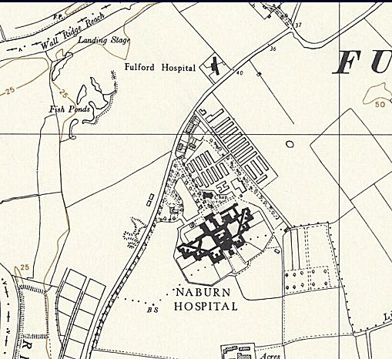
 | Ordnance Survey 1959
Ukrainian patients in the military hospital at Diss and that this is now the only such hospital in use for these cases. As regards the disposal of men who are not found suitable for retention in the United Kingdom as European voluntary workers, I would refer to the answer given on 16th June to the hon. Member for Bucklow (Mr. Shepherd)”. (House of Commons, 15 July 1948, Volume 453).

[Ukrainian members of the Waffen-SS Division Galizien were brought to England from a camp in Rimini. Those that remained in the UK were re-classified in 1948 from pows to European Volunteer Workers. The entry above indicates that some were at Naburn before being transferred to Diss.

Pow camp closed 1947.

After the camp: 1948 reverted to NHS use until 1988. 2019 outlet shopping centre.

Further Information:

