Camp 156 - The Heath Camp, Wellingore, Lincolnshire

1947 Camp list
156(G.W.C.) | The Heath Camp, Wellingore, Lincoln | N. | Priswar, Navenby | Navenby 334 | Navenby | Lt.Col.A.A.Johnson | v/1453/2

Prisoner of War Camps (1939 – 1948) - Project report by Roger J.C. Thomas - English Heritage 2003
OS NGR | Sheet | No. | Name & Location | County | Cond’n | Type 1945 | Comments
SK 983 554 | 121 | 156 | Heath Camp, Pottergate Plantation, Wellingore | Lincolnshire | 3 | German Working Camp | Former dispersed RAF camp

Location: About 1.5 km S of Wellingore  Before the camp: RAF camp opened 1917 as Wellingore Heath, then closed. Re-opened in 1935 and expanded to a full airfield during the winter of 1939/40. The RAF Camp closed in 1945.  Pow Camp: Reports that German and Ukrainian pows held here.  The camp is not listed as one of the main holding camps for Ukrainians when their status changed from pows in 1948. However, a couple of people searching for relatives have mentioned that Ukrainian pows here were first held at the camp in Rimini. This most likely means they were from the Waffen-SS Division Galizien which had been charged with war crimes.  Wellingore Hall was used as a mess for the RAF camp. It is reported that it was then used as an interrogation centre for pows – confirmation of this?  Camp commandant c.1947 Lieutenant Colonel A A Johnson (Suffolk Regiment?)  After the camp: The camp reverted back to farmland in the 1950’s. Wellingore Hall is a business centre and apartments.  Further Information:  Visible on RAF aerial photographs taken in April 1947 - RAF post war collection. Cpe/uk2009: 3445 | 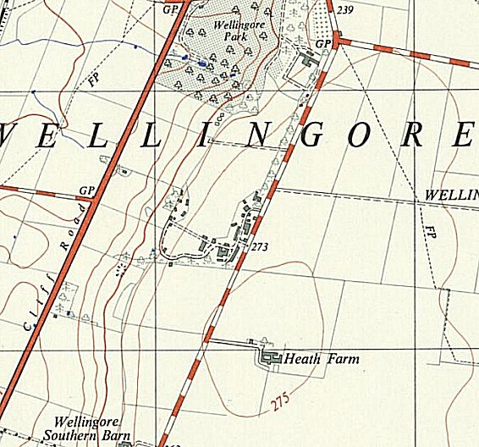
 | Ordnance Survey 1960

