Camp 154 - Ministry of Works Camp, Swanscombe, Kent

Included in the 1945 ICRC camp list – Labour Camp. 154. Min. of Works Camp, Swanscombe, Greenhithe, Nr.Dartford, Kent.

1947 Camp list
154(G.W.C.) | Ministry of Works Camp, Swanscombe, Greenhithe, Kent | E. | Priswar, Greenhithe | Gravesend 4797 | (Blank) | Lt.Col.P.H.W.Russell O.B.E. | v/1453/2

Prisoner of War Camps (1939 – 1948) - Project report by Roger J.C. Thomas - English Heritage 2003
OS NGR | Sheet | No. | Name & Location | County | Cond’n | Type 1945 | Comments
TQ 605 739 | 177 | 154 | Ministry of Works Camp, Swanscombe Street, Swanscombe | Kent | 4 | German Working Camp | Site occupied by housing

Location: Shows as Manor House Farm. Another record states – “The POW Camp was roughly where Brenda Terrace is today” – this would be the W edge of the map.  Before the camp: Farmland  Pow Camp:  There was a camp newspaper - Lagerstimme: Demokratische Lagerzeitung (The Camp Voice - Democratic Camp Newspaper).  Camp commandant c.1947 Lieutenant Colonel P H W Russell O.B.E., from the Royal Artillery.  After the camp: 2019 residential area.  Further Information:  National Archives FO 1120/228 – Re-educational survey visit reports for camps 151 to 154. Dated 1 January 1946 to 31 December 1948  IWM have a copy of the camp newspaper dated Christmas 1946 / January 1947. Catalogue LBY E.J. 383 | 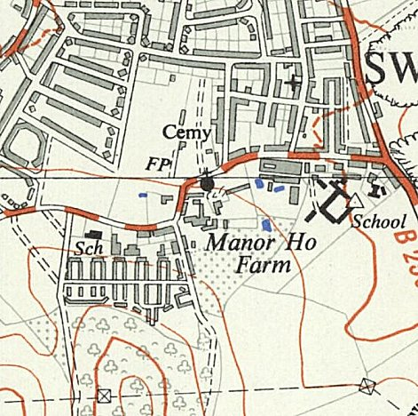
 | Ordnance Survey 1958

