Camp 153 - Fulney Park Camp, Spalding, Lincolnshire

Included in the 1945 ICRC camp list – Labour Camp. 153. Fulney Park, Spalding, Lincolnshire.

1947 Camp list
153(G.W.C.) | Fulney Park, Spalding, Lincs | N. | Priswar, Spalding | Spalding 2198 | Spalding | Lt.Col.C.T.Ingle | v/1453/2

Prisoner of War Camps (1939 – 1948) - Project report by Roger J.C. Thomas - English Heritage 2003
OS NGR | Sheet | No. | Name & Location | County | Cond’n | Type 1945 | Comments
TF272 222 | 131 | 153 | Fulney Park, Low Fulney, Spalding | Lincolnshire | 3 | German Working Camp | Formerly a large dispersed camp, currently a market garden

Location: Just to the E of Spalding. Huts dotted all over the place!  Before the camp:  Pow Camp: “Fulney Camp was built and used by the Army as a communications site during the war. After hostilities ceased, it was then used as a POW camp... The Camp covered about 5 or 6 acres, and included a reinforced concrete communications bunker, a large vehicle servicing workshop with underground fuel storage tanks, a cookhouse and mess, an entertainment hall complete with stage, together with numerous Nissen huts for accommodation, plus a brick-built ablutions building. There was also a hut built from insulated panels for use as a medical and sick-bay. The whole site was all served by a purpose-built sewage farm, with all the underground pipes being encased in concrete. It was therefore a self-contained unit, and luckily escaped any direct war damage. The site has all now been restored to its former pre-war state.” ( https://www.heritagesouthholland.co.uk/ )  Camp commandant c.1947 Lieutenant Colonel C T Ingle, from the Lincolnshire Regiment.  After the camp: Used for a while to house displaced persons. 2019 huge plant nursery.  Further Information:  National Archives FO 1120/228 – Re-educational survey visit reports for camps 151 to 154. Dated 1 January 1946 to 31 December 1948 | 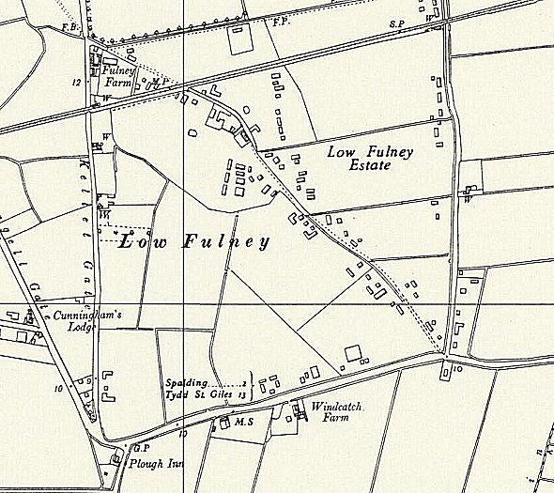
 | Ordnance Survey 1958

