Camp 152 - Old Liberal Club, Charnwood Road, Shepshed, Leicestershire

Included in the 1945 ICRC camp list – Labour Camp. 152. Old Liberal Club, Charnwood Rd, Shepshed, Loughborough, Leics.

Prisoner of War Camps (1939 – 1948) - Project report by Roger J.C. Thomas - English Heritage 2003
OS NGR | Sheet | No. | Name & Location | County | Cond’n | Type 1945 | Comments
SK 47 19 | 129 | 152 | Old Liberal Club, Charnwood Road, Shepshed | Leicestershire | 5 | German Working Camp

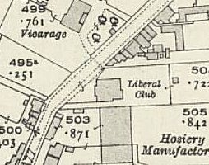  Location: Marked as ‘Club’ on map. (Liberal Club on 1921 OS insert). NGR SK 478 194  Before the camp: Liberal Club. Building from about 1902 / 6.  Pow Camp: Italian pows, then a German Working Camp.  Postal items: POW postcard January 1946 in Italian to Italy.  After the camp: 2019 Nursing home.  Further Information:  National Archives FO 1120/228 – Re-educational survey visit reports for camps 151 to 154. Dated 1 January 1946 to 31 December 1948 | 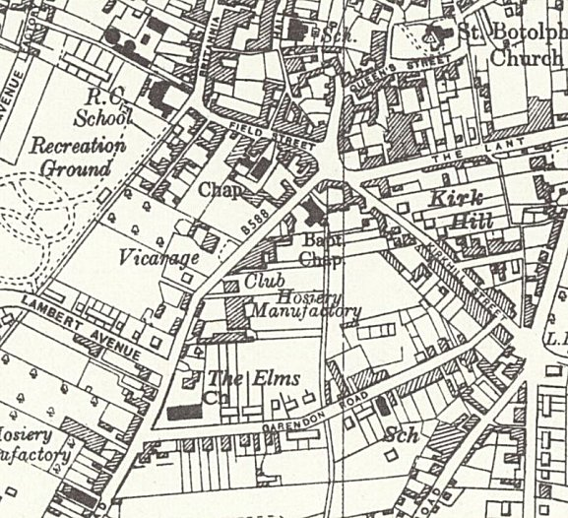
 | Ordnance Survey 1955

