Camp 151b - Halfpenny Green, Wolverhampton, Staffordshire

Prisoner of War Camps (1939 – 1948) - Project report by Roger J.C. Thomas - English Heritage 2003
OS NGR | Sheet | No. | Name & Location | County | Cond’n | Type 1945 | Comments
SO 823 910 | 138 | 151b | Halfpenny Green, Wolverhampton | Staffordshire | 2 |  | Former RAF airfield. Precise location not identified, NGR given for feature centre

Location: 11 km SW of Wolverhampton  Before the camp: The airfield was used as a RAF training centre from February 1941 to November 1945.  Pow Camp:  Probably linked to Camp 151 Pendeford and Camp 151a Coven Lawn  After the camp:  Further Information:  National Archives FO 1120/228 – Re-educational survey visit reports for camps 151 to 154. Dated 1 January 1946 to 31 December 1948 | 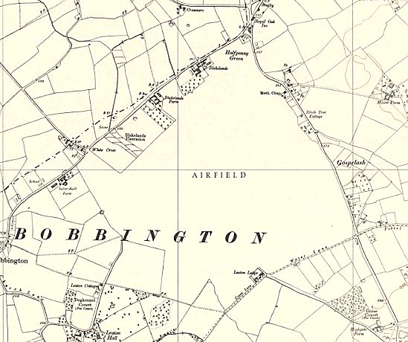
 | Ordnance Survey

