Camp 151a - Lawn Camp, Coven Lawn Camp, Coven Lane, Coven, Staffordshire (aka Coven / Lawne)

1947 Camp list
151(G.W.C.) | Lawne Camp, Coven, Wolverhampton, Staffs | W. | Priswar, Wolverhampton | Fordhouses 3221/2 | (Blank) | Lt.Col.A.W.Hawkins | v/1453/2

Prisoner of War Camps (1939 – 1948) - Project report by Roger J.C. Thomas - English Heritage 2003
OS NGR | Sheet | No. | Name & Location | County | Cond’n | Type 1945 | Comments
SJ 904 053 | 53 | 151a | Lawn Camp, Coven Lawn, Coven Lane, Coven | Staffordshire | 3 |  | Former Heavy Anti-aircraft battery (HAA Bty)

Location: NGR above as marked. Coven Lawn at SJ 906 059.  Before the camp: Fields  Pow Camp:  Probably linked with Camp 151 Pendeford and 151b Halfpenny green.  Camp commandant c.1947 Lieutenant Colonel A W Hawkins. (I think he was with the Green Howards).  After the camp:  Further Information:  National Archives FO 1120/228 – Re-educational survey visit reports for camps 151 to 154. Dated 1 January 1946 to 31 December 1948 | 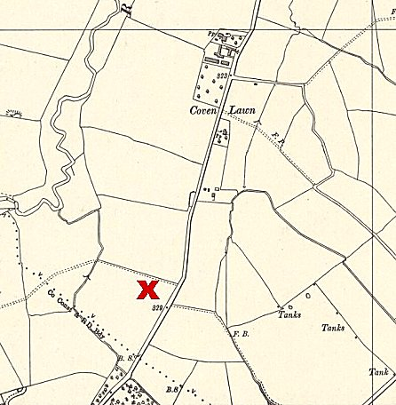
 | Ordnance Survey

