Camp 149 - Lee House, Romsey, Hants

Included in the 1945 ICRC camp list – Labour Camp. 149. Lee House, Romsey, Hampshire.

Location: NGR for Lee House is SU 359 192. About 2 km S of Romsey.  Before the camp: Farmland and house within the Broadlands Estate. Local history study states that Lee House was used during 1944 as a planning centre for the D-Day preparations, (Berrow, P., The Story of Romsey Local Heritage 1984).  Pow Camp:  After the camp:  Further Information: | 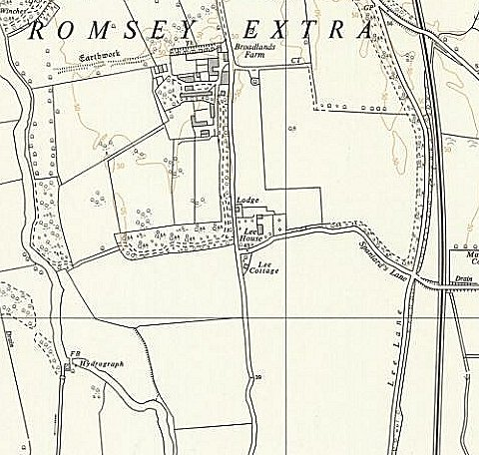
 | Ordnance Survey 1963

