Camp 148 - Castlethorpe (Hall) Camp, Castlethorpe, Lincolnshire

*? The ICRC listing for camp 148 is – ‘Labour Camp, 148. Sawcliffe, Lincolnshire.’ Sawcliffe is about 10 miles north-west of Brigg.

Prisoner of War Camps (1939 – 1948) - Project report by Roger J.C. Thomas - English Heritage 2003
OS NGR | Sheet | No. | Name & Location | County | Cond’n | Type 1945 | Comments
SE 986 078 | 112 | 148 | Castlethorpe Camp, Brigg | Lincolnshire | 3 | German  Working Camp | Consisted of 39 huts arranged on the west & north boundaries of Castlethorpe Covert and adjacent to a hardstanding north of Castlethorpe Hall. See Hostel list.

Location: The map shows some possible huts to the N of the Hall. To the W of Brigg.  Before the camp: Fields  Pow Camp:  After the camp: The main building is shown as Castlethorpe Nursing Home.  Further Information: | 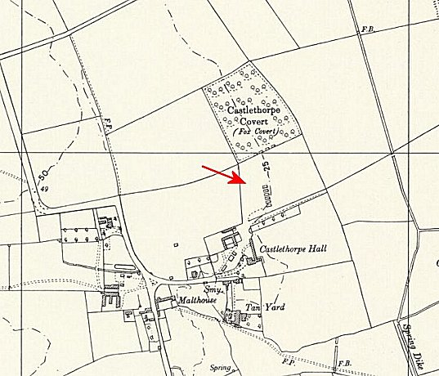
 | Ordnance Survey 1958

