**Camp 145** **- Normanhurst (Court) Camp, Battle, East Sussex**

Included in the 1945 ICRC camp list – Labour Camp. 145. Normanhurst Camp, Battle, Sussex.

|  |  |  |  |  |  |  |  |
| --- | --- | --- | --- | --- | --- | --- | --- |
| **1947 Camp list** | | | | | | | |
| 145(G.W.C.) | Normanhurst Court Camp, Battle, Sussex | E. | Priswar, Battle | Battle 258 | Battle | Lt.Col.A.C.Giles | v/1453/2 |

|  |  |  |  |  |  |  |  |
| --- | --- | --- | --- | --- | --- | --- | --- |
| **Prisoner of War Camps (1939 – 1948) - Project report by Roger J.C. Thomas - English Heritage 2003** | | | | | | | |
| OS NGR | Sheet | No. | Name & Location | County | Cond’n | Type 1945 | Comments |
| TQ 712 152 | 199 | 145 | Normanhurst Camp, Battle | Sussex (East Sussex) | 5 | German Working Camp | Precise location not identified, NGR given for Normanhurst, Steven's Crouch, Battle |

|  |  |
| --- | --- |
| **Location:** NGR for Normanhurst Court is TQ 712 149. Part of the estate surrounding a very large country house built for the Brassey family.    **Before the camp:** Country estate. During WW1 part of the estate was used as a military hospital. Once the family left between the wars it was used as a girls’ school.  **Pow Camp:** Italian pows then a German Working Camp.  Report that two POWs from Normanhurst shot themselves - one at Pigknoll Farm, the other at Wilson's Farm.  < Picture painted by pow Heinrich Engelhard of Normanhurst in August 1947. Appears to be Nissen type huts. I have been unable to trace a contact address for the site:  [www.whitehouse2002.co.uk/normanhurst.html](http://www.whitehouse2002.co.uk/normanhurst.html)  Another German artist, Matthias Hess, was also held at Normanhurst.  Satellite Camps / hostels listed for Normanhurst:  Hadlow Down  Halland  Herstmonceux |  |
| Ordnance Survey 1949 |

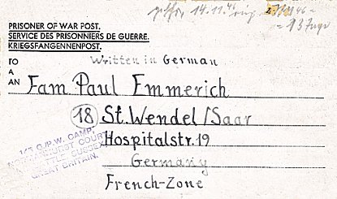Hollington

Hurst Green

Robertsbridge (on George Hill).

Wadhurst Park – in the grounds of Wadhurst Hall.

Camp commandant c.1947 Lieutenant Colonel A C Giles (I think he was with the Royal Warwickshire Regiment)

In German, dated 15 October 1944 >

**After the camp:** House demolished in 1951. Camping site.

**Further Information:**

National Archives FO 939/310 - 145 Working Camp, Normanhurst Court Camp, Battle, Sussex. Dated 1945 – 1948.