Camp 144 - Ruskin Avenue, Kew, Surrey

Included in the 1945 ICRC camp list – Labour Camp. 144. Ruskin Avenue, Kew, Richmond, Surrey.

Prisoner of War Camps (1939 – 1948) - Project report by Roger J.C. Thomas - English Heritage 2003
OS NGR | Sheet | No. | Name & Location | County | Cond’n | Type 1945 | Comments
TQ 196 771 | 176 | 144 | Ruskin Avenue, Kew | Surrey | 4

Location: The NGR places the site at what was the Ministry of Labour Offices at the end of Ruskin Avenue.  However, other information states: “There were Post Office stores along Occupation Road which were used as a POW camp for Italians in the Second World War. During the 1960s the site was redeveloped with the Crown Building (1967-69) and the Public Records Office (1973-77).” (http://www.kewriversidepark.org/about_us/ ). I do not know where Occupation Road was near to this site.  Before the camp: Ministry of Labour Office from the First World War. Single storey buildings. Civil servants left in 1940. During the war the offices were used to accommodate US troops and by American cartographers involved in mapping the D-day landings. And ‘later’ housing Italian pows.  Pow Camp: Reported to be up to 2000 Italian pows.  Postal items: POW letter-sheet 16 July 1945 in Italian to Sicily  After the camp: National Archives and residential area.  Further Information:  Can’t find anything at the National Archives ☺ | 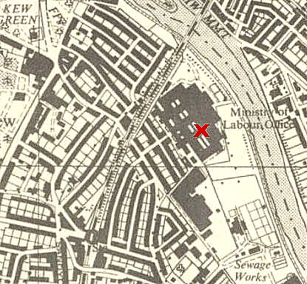
 | Ordnance Survey 1957

