Camp 143 - Serlby Hall Camp, Serlby, Blyth, Nottinghamshire

Prisoner of War Camps (1939 – 1948) - Project report by Roger J.C. Thomas - English Heritage 2003
OS NGR | Sheet | No. | Name & Location | County | Cond’n | Type 1945 | Comments
SK 634 893 | 111 | 143 | Serlby Hall Camp, Serlby, Blyth | Nottinghamshire | 5

Location: About 2.5 km NNE of Blyth..  Before the camp: Country mansion and estate. The house was an auxiliary military hospital during the First World War.  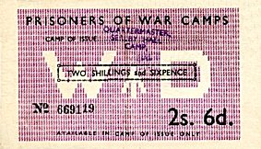  Pow Camp:  After the camp: Hall is Grade 1 listed. Believed to be in private ownership.  Further Information:  Link with C 143 Carlton Hall? | 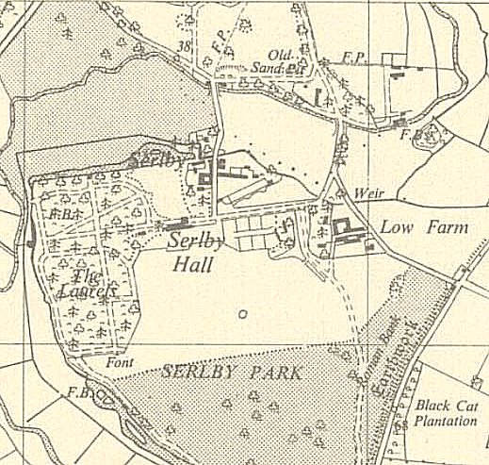
 | Ordnance Survey 1958

